Contents

Preface 2

Purpose 2

Scope 2

Introduction 2

Content Categories 3

Strategies for selecting closed vs open parts rooms 3

Parts room layout 3

Using VMRS or other numerical part numbering system to organize inventoried parts 6

Best practices for parts room cleanliness and proper lighting 7

Best practices for minimum and maximum ordering systems 8

Timing for parts charged out of inventory 8

Best practices for handling warranty parts 9

Best practices for handling core parts 9

Best practices for handling consumable parts 10

Setting goals for actual versus reported inventories 10

Conclusion 10

References 11

RP glossary 11

Preface

The following Recommended Practice is subject to the Disclaimer at the front of TMC’s Recommended Practices Manual. Users are urged to read the Disclaimer before considering adoption of any portion of this Recommended Practice.

# Purpose

The purpose of this Recommended Practice (RP) is to provide guidance and to assist in creating consistency within multiple parts inventory locations.

# Scope

This RP focuses on parts room standardization for fleets. It is not intended for retail or service providers since these groups will have different goals for inventory, etc.

# Introduction

This Recommended Practice (RP) lists guidance for the following categories:

* Strategies for selecting closed vs open parts rooms
* Parts room layout
* Using VMRS or other numerical part numbering system to organize inventoried parts
* Best practices for parts room cleanliness and proper lighting
* Best practices for minimum and maximum ordering systems
* Timing for parts charged out of inventory
* Best practices for handling warranty parts
* Best practices for handling part cores
* Best practices for handling consumable parts
* Setting goals for actual versus reported inventories

# Content Categories

## Strategies for selecting closed vs open parts rooms

(RJ) Consensus? Tentative consensus once phrases are reorganized.

One key component to parts room design is selecting an open or closed parts room approach based on the level of personnel access. Consider the number of employees accessing the inventory, as well as the frequency and volume of inventory movements to determine which setup best suits your space and workflow needs. The level of security and protection required for inventory as well as additional staffing are significant factors to consider when choosing between closed and open parts rooms.

Analyze the available space and how it aligns with your workflow requirements. Closed parts rooms offer enhanced security by restricting access to authorized personnel which will help to reduce variances between actual versus reported inventory counts. This approach can be particularly crucial for valuable or sensitive inventory items that require tight control and protection from theft or unauthorized handling. Conversely, open parts rooms provide quick access to repair parts by a broader number of employees without direct oversight. An open parts room approach may reduce staffing requirements, but could also lead to higher variances between actual versus reported inventory counts. If additional parts staffing is deemed necessary during this decision-making process, refer to *RP1605 Justification for a Part and Service Assistant*.

## Parts room layout

(Chelsea Seger) Consensus? Tentative consensus once phrases are reorganized.

Begin by designing a detailed floor plan of your parts storage area. Divide the space into rows, each containing a series of columns, and arrange shelves within each column. Number each row, column, and shelf accordingly for easy identification - see Figure #1 as an example.

If bins will be used to contain certain parts, consider the size and nature of your inventory items when determining the dimensions of the bins. Additionally, ensure that aisles between rows are wide enough to allow adequate movement of personnel and equipment. Please note that there may be minimum aisle widths required by local or state regulations.

After creating the layout, clearly label each bin location with its unique row, column, and shelf identifier. For example, a bin located in “Row A / Column 1 / Shelf A”, would be labeled as "A1A" – see figure #2. Use durable and visible labels that can withstand the wear and tear of daily operations. Adopting a consistent and standardized labeling system across the entire storage facility will help employees quickly locate and store items effectively.



Figure - potential parts shelf layout scheme with sequential part numbers

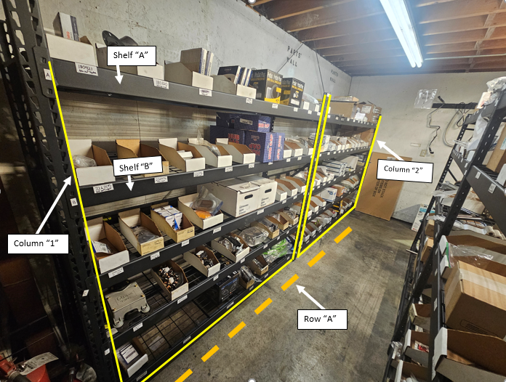

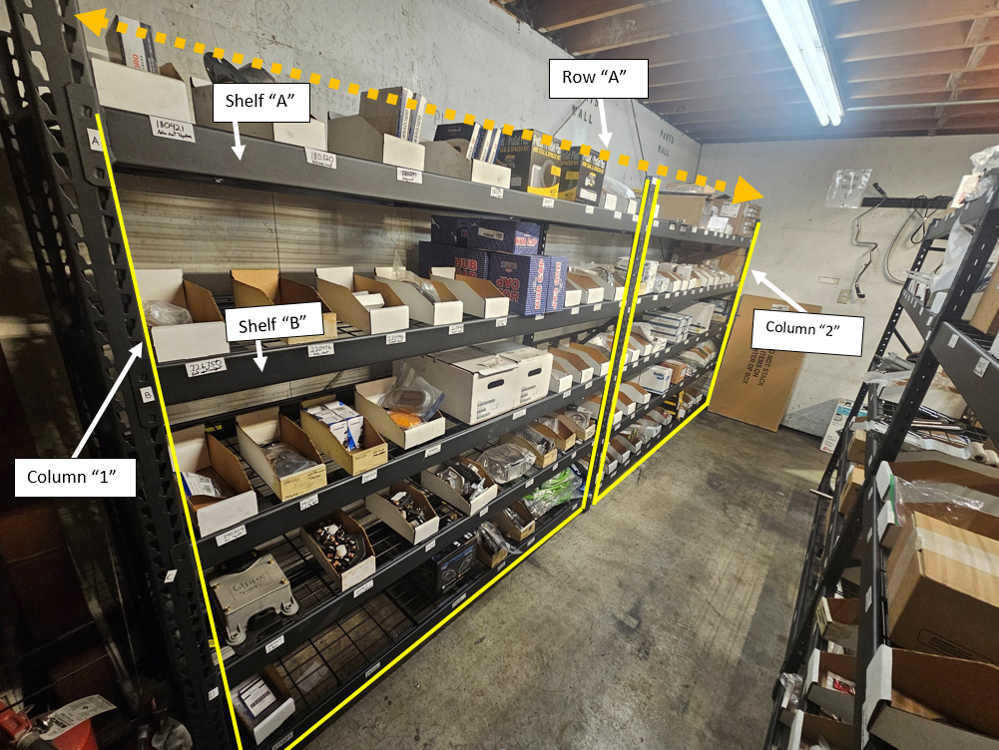

Figure - Row, column, shelf layout / part bins

## Using VMRS or other numerical part numbering system to organize inventoried parts

(TK) Consensus? Yes

Using a systematic approach when organizing parts helps to:

* enable quick identification,
* streamline the organizational process,
* minimize errors when handling parts.

One way to organize parts in the parts room is by using the VMRS Component Codes – Code Key 31. Refer to *RP802F TMC / ATA Vehicle Maintenance Reporting Standards* for additional information. Once the numerical system has been established, create clear and consistent labels for each inventoried part – see figure 3. Use durable tags or labels that prominently display each item's numerical code. Place labels visibly on each item or its container. If using bins or shelves for storage, ensure that the numerical code is also displayed on the respective locations. Consistency in labeling is crucial to avoid confusion and mistakes during the inventory management process. Consider the use of barcodes to label parts for an additional level of accuracy. Refer to *RP801C Bar Coding Guidelines* for additional information.

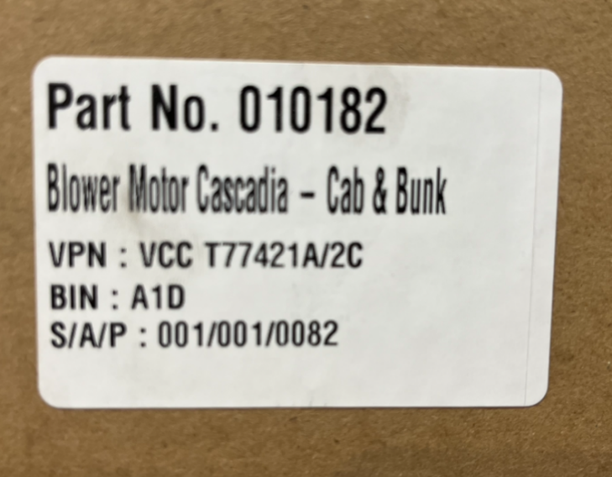

Figure 3 - VMRS associated part number w/ location

## Best practices for parts room cleanliness and proper lighting

(Chad) Consensus? Not yet

Keeping the parts room clean and organized is essential to prevent damage to inventory items and to maintain their quality. Regular cleaning reduces the risk of contaminants entering sensitive components, and helps to eliminate dust, dirt, and debris that can accumulate on stored parts over time. Adhering to cleanliness and organization standards will aid in improving inventory accuracy, reduce damaged items, and create a more efficient workflow for inventory management.  
 Adequate lighting in the parts room is paramount for ensuring that employees can easily locate, inspect, and handle inventory items. Overhead fixtures should be placed between aisles to illuminate the parts on the shelves properly. Additional lighting solutions, such as overhead lights, task lights, or LED strips, ensure that every corner of the part room is well-lit and help staff to identify part numbers and to check item conditions in a safe and effective manner. See figure 4 as an example of adequate lighting.

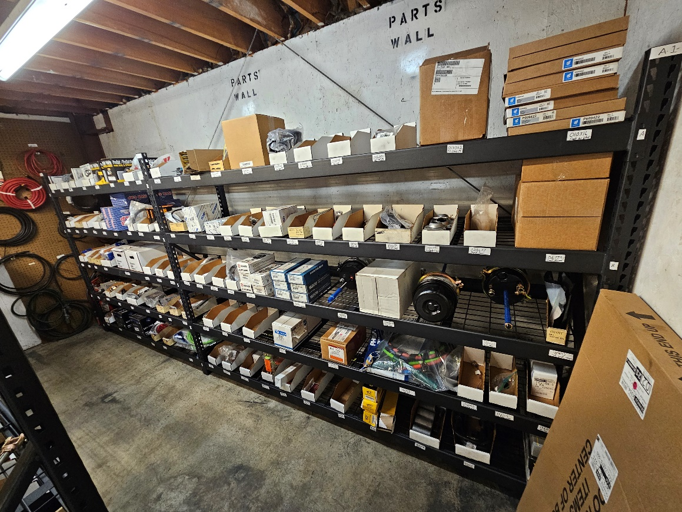

Figure - proper lighting and cleanliness

## Best practices for minimum and maximum ordering systems

(Wayne) Consensus? Yes

Successfully implementing a minimum and maximum (min/max) ordering system for repair parts helps to reduce unnecessary inventory while maximizing space within the parts room. Users should utilize historical usage data and supply chain data to predict future demand as accurately as possible. By understanding the fluctuations in demand, users can set appropriate minimum and maximum stock levels for each item. Users should avoid relying on intuition or ad-hoc approaches, as these may lead to overstocking or stock outs, both of which can negatively impact your ability to complete timely repairs. Inventory demand and supply chain conditions are subject to change which should influence your inventory’s min/max order quantities. Users should periodically review and adjust the ordering system parameters based on real-time data and trends. Implementing a review schedule will help to align the min/max parameters with the specific needs of the business, respond to seasonality, and account for new product launches. For additional information, refer to refer to section: “*Physical Inventory Counts*” located within *RP531 Parts Inventory Management Guidelines*.

## Timing for parts charged out of inventory

(Chad) Consensus? Not yet

Inventory parts should be charged to an asset as the part leaves the parts room to help ensure that reported inventory levels properly match the physical inventory in the parts room. In a closed parts room, parts room staff should charge the part to the repair order prior to issuing the part to a technician. In an open parts room, the technician should have the ability to enter or scan the part to a repair order prior to removing the part from the parts room. Providing a streamlined method for users to charge out parts minimizes the risk of parts leaving the parts room without being accounted for on a repair order. For additional information, refer to section: “Establish Parts Charging Out Policy” located within *RP531 Parts Inventory Management Guidelines*.

## 

## Best practices for handling warranty parts

(Stuart Doane) Consensus? Yes – based on comment.

Identify a specific area of the parts room specifically for warranty parts awaiting disposition from the supplier. Historical warranty records should be reviewed to determine the appropriate amount of space required to store warranty parts. Warranty parts should be clearly tagged and identified, and organized in accordance with established policies and procedures. Warranty parts should not be disposed of until directed by the supplier.

## Best practices for handling core parts

(Stuart Doane) Consensus? Update language – see notes

Similar to warranty parts, core parts should have a designated area within the parts room. Each core should be linked to the corresponding new part that is charged out. For damaged or other non-reusable cores, a responsible recycling program should be in place to dispose of these components in an environmentally friendly manner. For additional guidance on effective handling of core parts, refer to *RP1615 Parts Core Management for Service Providers*.

## Best practices for handling consumable parts

(TK) Consensus? Yes

A method of ensuring adequate inventory of consumable parts should be implemented. As consumable items are typically not stocked, counted, and billed as parts; an alternate method of maintaining inventory levels needs to be utilized. Identifying a shelf or shelves for these types of items, labeling with minimum/maximum quantities, and physically counting these items each week is one way to ensure that enough product is on-hand to meet the needs of the shop.

A common method of accounting for the use of consumables follows placing these items into inventory via the purchase order (PO) system, and applying these consumable supplies to a repair order (RO) every month to relieve the inventory. Consult with your Fleet Maintenance Management Software (FMMS) supplier to assist in determining the best method for your operation. For additional guidance, refer RP531 Parts Inventory Management Guidelines.

## Setting goals for actual versus reported inventories

(Wayne) Consensus? Yes – but concerns if better in RP531

Once the parts room set-up process has been completed, establish goals for actual versus reported inventories to promote accuracy and accountability within the organization. By regularly comparing physical inventory counts to the recorded quantities, discrepancies can be quickly identified and addressed. Setting specific targets for minimizing discrepancies encourages employees to take ownership of inventory management, leading to better record-keeping practices, a reduction in inventory errors, and will aid in maximizing storage space. While each company will need to determine their specific variance goal, managers should consider requiring an action plan to address the root cause for discrepancies above the approved threshold. For additional information, refer to refer to section: “*Physical Inventory Counts*” located within *RP531 Parts Inventory Management Guidelines*.

# Conclusion

Need consensus

Whether a fleet operates a single parts room, or several inventory locations - the development of strategies to process and organize parts in a consistent manner will help to maximize space utilization and reduce inventory losses. Ensuring that parts areas are clean, organized, and well-lit will also support a safe work environment and aid in employee efficiency and morale.

# References

* RP530 Fleet Guidelines for Parts Purchasing
* RP531 Parts Inventory Management Guidelines
* RP801C Bar Coding Guidelines
* RP802F TMC / ATA Vehicle Maintenance Reporting Standards
* RP1605 Justification for a Part and Service Assistant.
* RP1615 Parts Core Management for Service Providers

# RP glossary

* **Fleet Maintenance Management Software (FMMS)** – a software platform designed to manage repair orders, preventive maintenance schedules, inventory management, and additional fleet-related activities and tasks.
* **Open Parts Room** – Parts rooms that are accessible to technicians, parts installers, and other employees.
* **______________**?
* **______________**?