**RP 185 – WIP 2024 VMRS 052-011**

ELECTRICAL INFRASTRUCTURE, SAFETY, AND INTEROPERABILITY FOR TRANSPORT REFRIGERATION SHOREPOWER

# PREFACE

The following Recommended Practice is subject to the Disclaimer at the front of TMC's *Recommended Engineering Practices Manual.* Users are urged to read the Disclaimer before considering adoption of any portion of this Recommended Practice.

# PURPOSE AND SCOPE

Electrical grid power has been used to operate transport refrigeration systems for many years. Some electrically powered transport refrigeration unit (eTRU) systems rely solely on grid power for cooling while others use a combination of methods.Disparate and outdated connection systems are sometimes a barriertopowereTRUs.This Recommended Practice (RP) defines the terminology and specifications for high-voltage, temporarily tethered (or "shorepower") truck, tractor or eTRU systems (high-voltage being defined as greater than 60 volts up to 600 volts AC root mean square (RMS) or 1000 volts DC.) Fleets should review their procedures and safety policies for use and handling of high voltages.

This RP will identify electrical power and connection systems commonly used for eTRUs. It will cover the following topics associated with eTRU operation:

* Operating Voltage
* Wire and Cable
* Cord Management
* Mobile Equipment Connection Procedures
* Connector Types
* Dock and Pedestal Connections
* Safety Agency Listing
* Signage and Labeling
* Specialized Options and Features

This RP cites technical terms and industry stan­ dards that define specifications and their related performance. This RP does not explain these terms and standards in detail. They are only listed to show what standard may be specified to obtain the stated electrical equipment.

# INTRODUCTION

This RP provides descriptive information about spe­ cific electrical apparatus, wire, cable and associated devices for the purpose of informing the potential user of available options without preference or intent to any specific manufacturer or market. Information provided herein should not be substituted for national/ local building codes, equipment provider operating requirements or user-specific policy or procedures.

Historically, the electrical power available for eTRUs has been determined by the site electrical infrastruc­ ture.Most sites were not originally designed for large scale eTRU deployment. Connection systems are also commonly continued from legacy systems and infrastructure.

# OPERATING VOLTAGES

eTRU power requirements need to be matched to appropriately rated utility connections.Both single and multi-phase power connections are used to operate eTRU's. In general,lower-capacity refrigeration units use lower voltages and/or single-phase operation while higher-capacity units require higher voltages and multi-phase power. Higher-capacity units that require multi-phase power will usually have options to support different multi-phase voltages.

Typical North American,60Hz operating voltages are:

* **Single Phase:** 120V, 240V, 277V, 347V
* **Multi-Phase:** 208V, 460V, 480V, 600V

These voltages are in the ranges that should be ad­ dressed by specific fleet safety policy and operating procedures and practices.

# WIRE AND CABLE

In current practice, Underwriters Laboratory (UL) standard wire and cable types have been used both between the shorepower and the eTRU connection point as well as within the trailer or truck body, eTRU and associated conduits (see **Figure 1).** While at

© **2020-TMC/ATA Issued 4/2020**

|  |  |
| --- | --- |
| /Jackel  **Conductor A** | |
|  | **Conductor 8** |
|  |

### Figure 1: UL-style Unshielded High-Voltage Cable (Orange Color) With Multiple Inner Conductors With a Nominal System Voltage Up to 1000 Volts

least partially non-applicable to mobile equipment, the general compliance standard has been the Na­ tional Electric Code (NEC). In recent practice, SAE International standards have been created to reflect the use of higher voltage wiring and systems within the passenger and commercial vehicle market.

### Conductor

For transport refrigeration applications, high-voltage wiring is required on the truck or trailer to connect the grid shorepower supply connection to the refrig­ eration unit's electrical system. This wiring can be compromised of cable or of individual conductors. These conductors can be run in conduit or contained in a multi-conductor cable.

**NOTE:** When running multi-conductor cable or indi­ vidualconductors in conduit for protection,it requires proper evaluation of temperature rating effects and possible de-rating of current carrying capacity.

Conduit fillcan be determined based on NEC Conduit fill calculations, however, full load operating tempera­ tures within the conduit need to be within the limits of the conductor insulation temperature specifica­ tion. The conduit itself should also be rated for the environment and operationaltemperature transitions.

### Insulation and Jacket

For wiring installed on the truck, trailer or combina­ tion vehicle, the color orange is recommended to be used for cable insulation and jacket when voltages are greater than 60 volts per SAE EA-1128, "Wire Color Chart" (see **Figures 2 and 3).**

Conduit, braiding or other wire coverings used for high voltage applications may also be used to comply with orange color recommendations. This applies to equipment energized when stationary and/or in­ motion. In addition, the cable should conform to the requirements specified in SAE J1654, "Unshielded

### Figure 2: SAE J2840 High-Voltage Shielded and Jacketed Cable (Orange Color) With a Nominal System Voltage Up to 1000 Volts

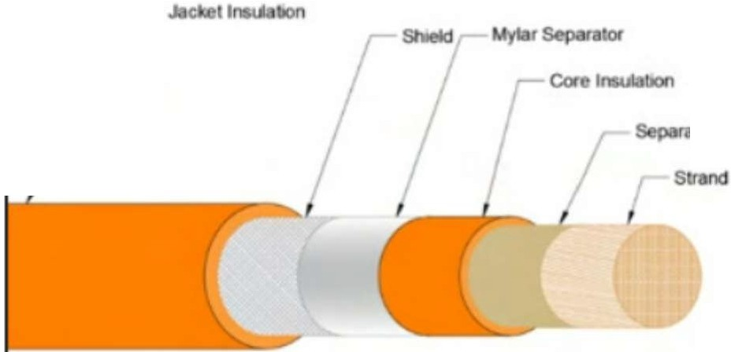

*I* IOr

/ Jacket Insulalion

*I*

Separator

/ **Strand**

**Figure 3: SAE J1654 Unshielded High-Voltage Cable (Orange Color) With a Nominal System Voltage Up to 1000 Volts**

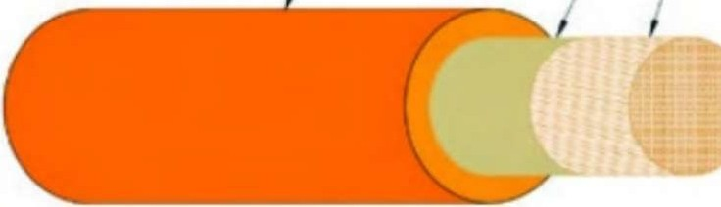High-Voltage Primary Cable" or SAE J2840, "High­ Voltage Shielded and Jacketed Cable." All SAE stripe colors may be used to further identify each individual circuit.

The cord used to connect the grid power to the eTRU and that is not part of the truck, trailer or combina­ tion vehicle does not need to be colored orange. It should be an outdoor-rated cord. National Electrical Manufacturers Association (NEMA) Type W cable is common. Consult the applicable local electrical codes for the cable types accepted for a particular installation.

### Temperature Ratings

For **Non-engine and Cool Ambient Areas,** the temperature class rating should be 85°C (185°F) minimum for these cables.

For **Engine and HotAmbientAreas,** the temperature class rating should be 125°C (257°F) minimum of thermosetting materials for added application safety.

### Cord Management

Cords used to connect shorepower to the eTRU should be properly coiled and stored when not con­ nected. When connected, cords should be routed away from walkways.

Retractable and retractile cords can be used for these connections but require additional preventive maintenance reviews and will likely have a shorter overall service life. All cables and wiring used in portable applications should be regularly inspected and tested per company safety program policy.

## MOBILE EQUIPMENT CONNECTION PROCEDURES

Hardware selected to connect mobile equipment (including eTRUs) to electrical power can vary, but is generally restricted to approved standard wiring devices. Different types of wiring devices have differ­ ent use-case, safety and operational requirements. Proper use of these devices depends on their rating and facility policies. For example, not all disconnect means are approved as an operational disconnect. Users are advised to shut down equipment prior to connecting or disconnecting shorepower. These procedures may vary due to location, equipment, original equipment manufacturer (OEM) applicable procedures and company policy.

Fleet operational and safety programs should include proper procedures for equipment operation,including transport refrigeration systems. Cords used to con­ nect toe TRUs should be routed away from footpaths andtraffic areas.Cords and connector ends,including mobile equipment connections, should be inspected for damage, contamination or abuse prior to making the connection.

## CONNECTOR TYPES

### Twist-Lock Types

Single and multi-phase twist-lock connection systems are currently the most commonly used types (see **Figures 4 and 5).**They are not commonly water-tight connections and are generally not recommended for new installations. These types can include, but are not limited to (only receptacle types shown):

### Single Phase

* + L5-15R, L5-20R
  + L5-20R, L6-20R, L14-20R
  + L5-30R, L6-30R, L14-30R

### Three Phase

* + L11-20R, L11-30R
  + L12-20R, L11-30R

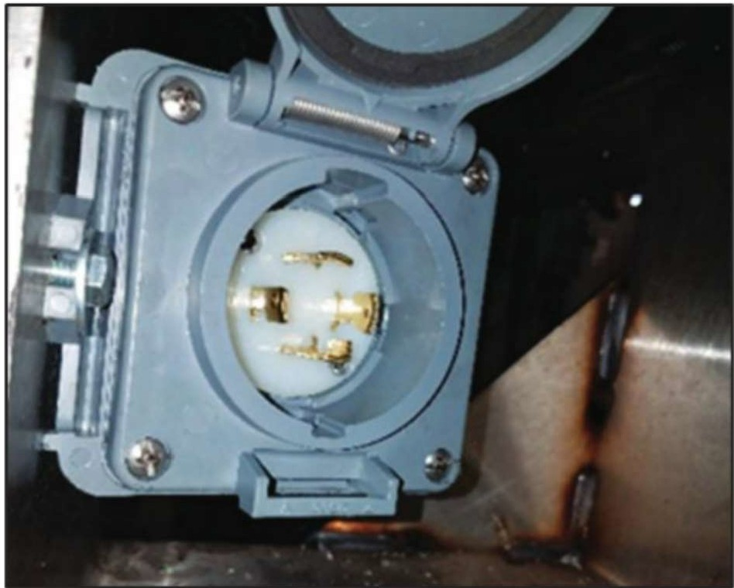

### Figure 4: Twist-Lock Style Connector, Trailer Connection

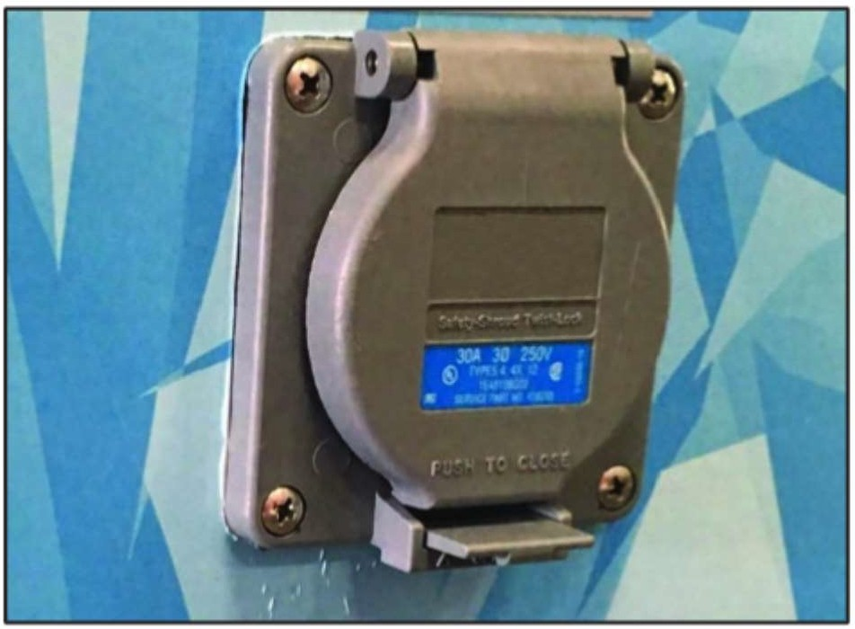

**Figure 5: Twist-Lock Style Connector, Vehicle-Mounted Connection**

L15-20R, L15-30R L16-20R, L16-30R L18-20R, L18-30R L19-20R, L19-30R L21-20R, L21-30R H37

H38

### Pin and Sleeve Types

Pin and sleeve connections are used for multi-phase, high-power equipment that require weather-tight connections (see **Figure 6).** There are many differ­ ent types of pin and sleeve connectors. Although configurations may vary, the following are commonly used for eTRU applications:

* + IEC 60309 Red 3P+E, 6h
  + IEC 60309 Blue 3P+N+E, 9h

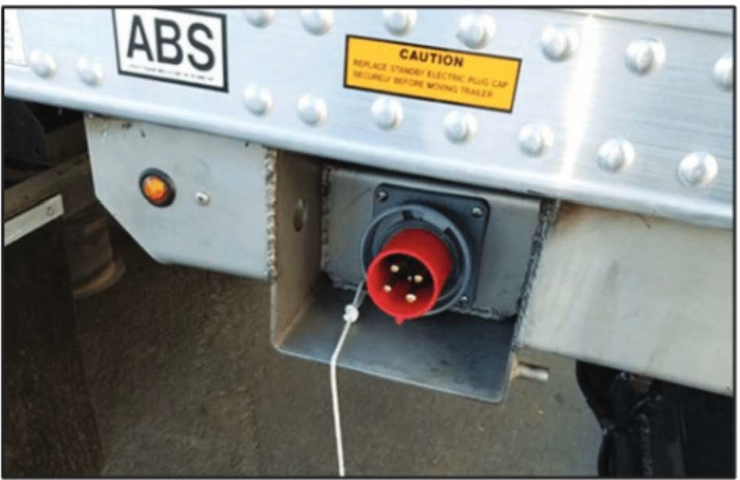

### Figure 6: Pin and Sleeve Style Connector, Vehicle-Mounted Connection

* + IEC 60309 3P+E+ 2 Auxiliaries
  + UL 1682 3P+E+ 2 Auxiliaries
  + UL 2682, various configurations
  + CSA 182.1 various configurations

### Other Types

Several connector and equipment suppliers offer an option to the standard connection systems. These may include specific features that fleets may find attractive. Features may include:

* + dead front operation. motor disconnect rated.
  + self-ejecting / drive-off protection.
  + breakaway protection (see **Figure 7).**
  + Incorporation of signal-level connections.
  + Mobile Equipment Connection Location.

Proper connection location, selection and installa­ tion is key to long-term performance and reliability. TMC recommends that eTRU connections be on the driver/road side of the equipment. This positioning

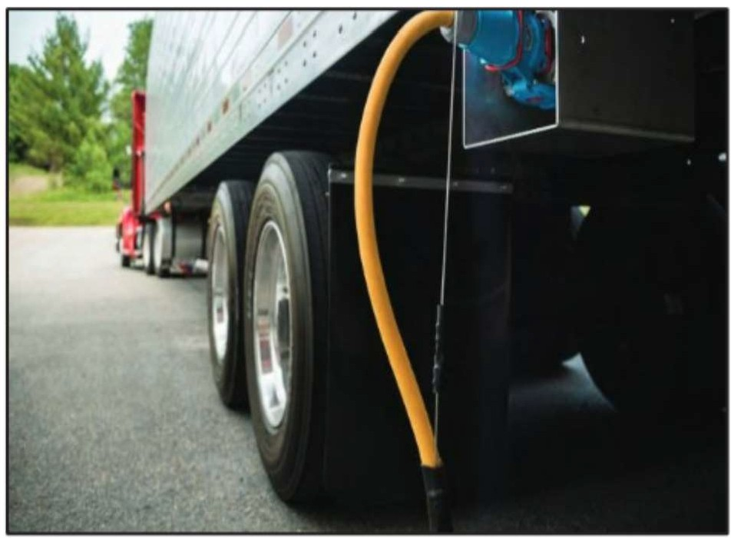

### Figure 7: Breakaway Style Connector, Trailer Connection

will allow for a higher level of awareness of the status of the connection.

Installation of the plug at the rear of the trailer or truck may make **it** easier to route connection cords away from foot and vehicle traffic areas. The connection should be protected from impact and include features to seal the connector contacts from water intrusion when mated or unmated.Connection contacts should be cleaned and inspected during normal preventive maintenance events.

### Dock and Pedestal Connections

Dock-side connection hardware should be mounted securely adjacent to the dock door on the road or driver side of the dock (see **Figure 8).**

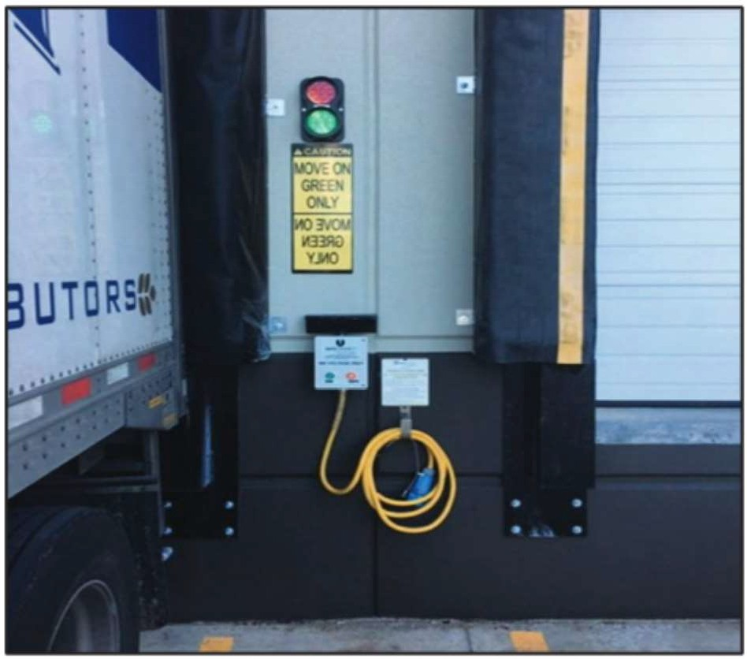

### Figure 8: Breakaway Style, Dock Door Connection - Outdoor With Disconnect

Pedestals can be used where there are no adjacent structures or where eTRU's need to be powered away from a loading dock (See **Figures 9, 10 and 11).**

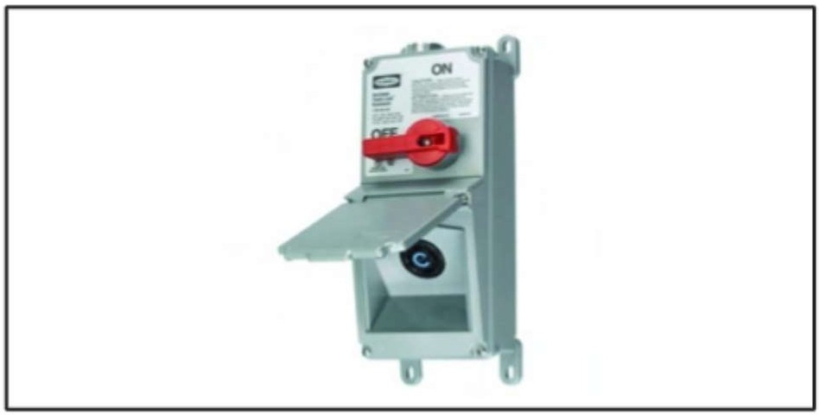

**Figure 9: Twist-Lock Style Connection** -

**Outdoor With Disconnect**

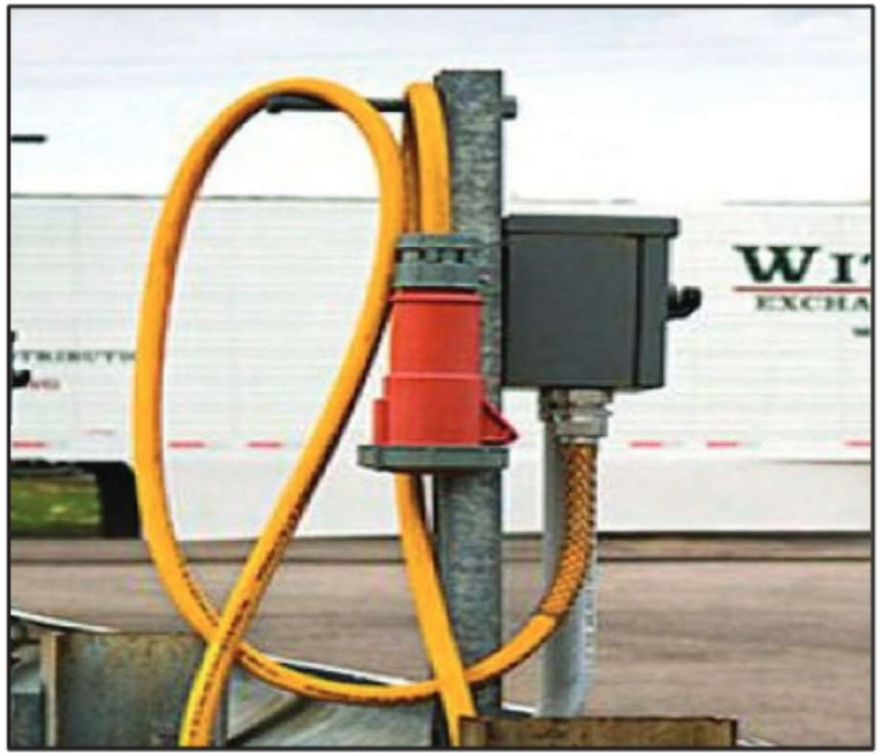

**Figure 10: Pin and Sleeve Style Connection** -

**Outdoor With Disconnect**

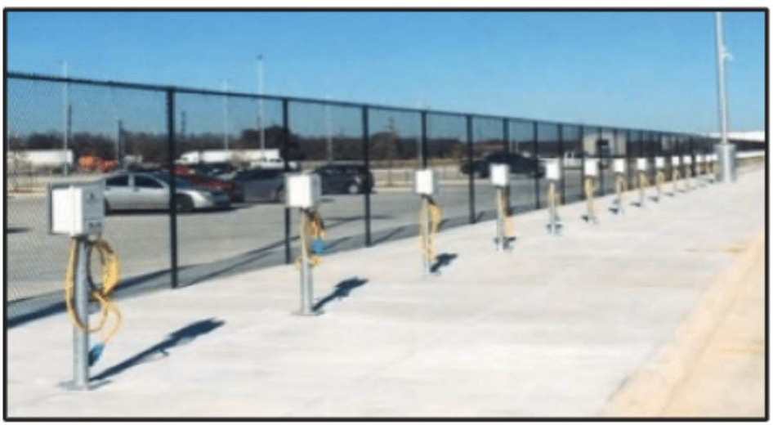

**Figure 11: Breakaway Style, Pedestal Connection - Outdoor**

Adapters for connector types may be provided in cases where voltages and current requirements of the eTRU are met and local codes allow for adapters to be used. Dockside and pedestal system providers are encouraged to provide a variety of common con­ nections including single and multi-phase voltages.

## SAFETY AGENCY LISTING CONSIDERATIONS

All fixed location and connection hardware should be listed by the appropriate listing service and rec­ ognized as acceptable per the applicable local and national electrical codes.

## SIGNAGE AND LABELING

### Nameplates

All equipment and connection systems should be labeled with equipment nameplates indicating cer­ tifications, listings, voltage, current and applicable nomenclature.

### Safety Signage

All equipment and connection systems should be labeled following NEC, NFPA, OSHA and other agency and administrative requirements. TMC RP 524, *Advisory Annotation Guidelines,* defines three advisory terms in keeping with ANSI Z535.4:Danger, Warning, and Caution:

Activities associated with Danger indi­ cate that death or serious personal injury may result from failing to heed the advisory. Serious personal injury may be equated to career-ending injury.

 Activities associated with Warning indicate that personal injury may result from failing to heed the advisory. In this case, personal injury is not equated to career-ending injury, but results in possible change in quality of life.

Activities associated with Caution indicate that product damage may result from failing to heed the advisory. Caution is not used for personal

injury.

## SPECIALIZED EQUIPMENT AND FEATURES

Unique connection options are available that provide features specific to application and customer prefer­ ence.

.These features may include:

* + Breakaway or self-ejecting connections that limit damage due to drive-offs while connected
  + Control systems to disconnect power at source and de-energize cord.
  + Payment options for pay-as-you-go power.

## REFERENCES

* + TMC RP 184, *High Voltage Cable for Heavy Duty Truck Tractor Wiring Systems*
  + TMC RP 524, *Advisory Annotation Guidelines* SAE EA-1128,"Wire Color Chart," SAE Interna­ tional,400 Commonwealth Drive,Warrendale, PA 15096.

SAE J1127, "Low Voltage Battery Cable." SAE J1128, "Low Voltage Primary Cable." SAE J1654,"Unshielded High Voltage Primary Cable."

SAE J2840,"High Voltage Shielded and Jack­ eted Cable."

SAE J2698, "Primary Single Phase Nominal 120 VAC Wiring Distribution Assembly Design

- Truck and Bus," design and application of primary on-board wiring distribution system harnessing for surface vehicles for single­ phase nominal 120-volt AC circuits.

IEC 60309, "Plugs, Socket-Outlets And Cou­ plers For Industrial Purposes," International Electrotechnical Commission (IEC), PO Box 131, 1211 Geneva, 20 Switzerland.

* + UL 1682, "Plugs, Receptacles, and Cable Connectors of the Pin and Sleeve Type," 333 Pfingsten Road, Northbrook, Illinois, 60062
  + UL 2682, "Outline of Investigation for Switch­ Rated Plugs and Receptacles."
  + CSA C22.2 NO 182.1, "Plugs, receptacles, and cable connectors of the pin and sleeve type," CSA Group,178 Rexdale Blvd.,Toronto, Ontario M9W 1R3 Canada.