Contents

Preface 2

Purpose 2

Scope 2

Introduction 2

Content Categories 2

Best practices for implementing and utilizing minimum and maximum ordering systems. 2

Setting goals for actual versus reported inventories. 4

Strategies for selecting closed vs open parts rooms. 4

Guidance on how to set up and define bin locations by row, column, and shelf. 5

Guidance on inventory timing for dormant parts. 5

Process for disposing of dormant or obsolete parts. 6

Guidance on how to process unused and / or unusable parts in inventory. 6

Best practices for handling warranty parts 7

Best practices for handling part cores. 7

Ways to organize inventoried parts using VMRS or other numerical part numbering system. 8

Best practices for handling consumable parts. 9

Best practices for parts room cleanliness and proper lighting. 10

Timing for when parts should be charged out of inventory. 11

Conclusion 11

References 11

RP glossary 11

Preface

The following Recommended Practice is subject to the Disclaimer at the front of TMC’s Recommended Practices Manual. Users are urged to read the Disclaimer before considering adoption of any portion of this Recommended Practice.

# Purpose

The purpose of this Recommended Practice (RP) is to provide guidance to fleets and to assist in creating consistency within multiple parts inventory locations.

# Scope

This RP focuses on parts room standardization for fleets. It is not intended for retail or service providers since these groups will have different goals for inventory, etc.

# Introduction

This Recommended Practice (RP) lists guidance for the following categories:

* Best practices for implementing and utilizing minimum and maximum ordering systems.
* Setting goals for actual versus reported inventories.
* Strategies for selecting closed vs open parts rooms.
* Guidance on how to set up and define bin locations by row, column, and shelf.
* Guidance on inventory timing for dormant parts.
* Process for disposing of obsolete parts.
* ~~Guidance on how to process unused and / or unusable parts in inventory.~~
* Best practices for handling warranty parts
* Best practices for handling part cores.
* Ways to organize inventoried parts using VMRS or other numerical part numbering system.
* Best practices for handling consumable parts.
* Best practices for parts room cleanliness and proper lighting.
* Timing for when parts should be charged out of inventory.

# Content Categories

## Best practices for implementing and utilizing minimum and maximum ordering systems.

(Wayne) Consensus? Yes

The foundation of a successful minimum and maximum (min/max) ordering system lies in accurate demand forecasting. Users should utilize historical usage data, market trends, and supply chain data to predict future demand as accurately as possible. By understanding the fluctuations in demand, users can set appropriate minimum and maximum stock levels for each item. Users should avoid relying on intuition or ad-hoc approaches, as these may lead to overstocking or stock outs, both of which can negatively impact your ability to complete timely repairs. Inventory demand and supply chain conditions are subject to change which should influence your inventory’s min/max order quantities. Users should periodically review and adjust the ordering system parameters based on real-time data and trends. Implementing a review schedule will help to align the min/max parameters with the specific needs of the business, respond to seasonality, and account for new product launches. Employing effective inventory management software can greatly enhance the effectiveness of your min/max ordering system. Modern software solutions allow users to automate the monitoring and replenishment process, generating reorder points, and suggesting optimal order quantities based on historical data and demand patterns. By leveraging technology, users can significantly reduce the manual effort involved in managing inventory, mitigate the risk of human errors, and improve overall inventory control. Refer to RP531 Physical Inventory Counts for additional information.

## Setting goals for actual versus reported inventories.

(Wayne) Consensus? Yes

Establishing goals for actual versus reported inventories promotes accuracy and accountability within the organization. By regularly comparing physical inventory counts to the recorded quantities, discrepancies can be identified and addressed promptly. Setting specific targets for minimizing discrepancies encourages employees to take ownership of inventory management, leading to improved attention to detail, better record-keeping practices, and a reduction in inventory errors. Reviewers should also have a process to prevent and ultimately account for kitted parts with missing components. While each company will need to determine their specific variance goal, managers should consider requiring an action plan to address the root cause for discrepancies above the approved threshold. Refer to RP531 Physical Inventory Counts for additional information.

## Strategies for selecting closed vs open parts rooms.

(RJ) Consensus? Tentative consensus once phrases are reorganized.

The level of security and protection required for inventory is a significant factor in choosing between closed and open parts rooms. Closed parts rooms, such as locked storage areas or cabinets, offer enhanced security by restricting access to authorized personnel only. This can be particularly crucial for valuable or sensitive inventory items that require tight control and protection from theft or unauthorized handling. Conversely, open parts rooms with access to open shelves and bins, may be suitable for less valuable or non-sensitive parts that are frequently accessed and replenished. In this case, the focus is on ease of access and efficient picking rather than strict security measures.

Consider the level of inventory visibility and accessibility required for efficient operations. Open parts rooms provide better visibility of inventory levels, allowing employees to quickly identify items that need restocking or those that are close to reaching minimum levels. This visual transparency can facilitate just-in-time inventory management and improve order fulfillment speed.

Analyze the available space and how it aligns with your workflow requirements. ~~Closed parts rooms with compact storage solutions, such as high-density shelving or automated retrieval systems, can help maximize the use of limited space while ensuring organized storage. Open parts rooms with well-structured layouts can optimize picking processes, reduce travel time, and improve overall workflow efficiency~~. Consider the frequency and volume of inventory movements, as well as the number of employees accessing the inventory, to determine which setup best suits your space and workflow needs. For decision making on adding parts personnel, please refer to RP1605 Justification for a Part and Service Assistant.

## Guidance on how to set up and define bin locations by row, column, and shelf.

(Chelsea Seger) Consensus? Tentative consensus once phrases are reorganized.

Begin by designing a detailed floor plan of your storage area. Divide the space into rows, each containing a series of columns, and arrange shelves within each column. Number each row, column, and shelf accordingly for easy identification. Consider the size and nature of your inventory items when determining the dimensions of the bins. Additionally, ensure that aisles between rows are wide enough to allow smooth movement of personnel and equipment. Please note that there may be minimum aisle widths required by local fire chief or state fire Marshall offices.

After creating the layout, label each bin clearly with its unique row, column, and shelf identifier. For example, a bin located in Row A, Column 1, Shelf A, would be labeled as "A1A" – see Figure #1. Use durable and visible labels or barcode stickers that can withstand the wear and tear of daily operations. Adopting a consistent and standardized labeling system across the entire storage facility will help employees quickly locate and store items, even if they are new to the system.

Implement an inventory management software system to track item locations, quantities, and movements accurately. With the help of the software, you can easily update the inventory records whenever items are moved or restocked. The software can also generate real-time reports, ensuring that you always have a clear picture of your inventory levels and can efficiently plan for restocking or reordering. Moreover, the system will enable you to identify any slow-moving or fast-selling items, improving your overall inventory control and decision-making process.

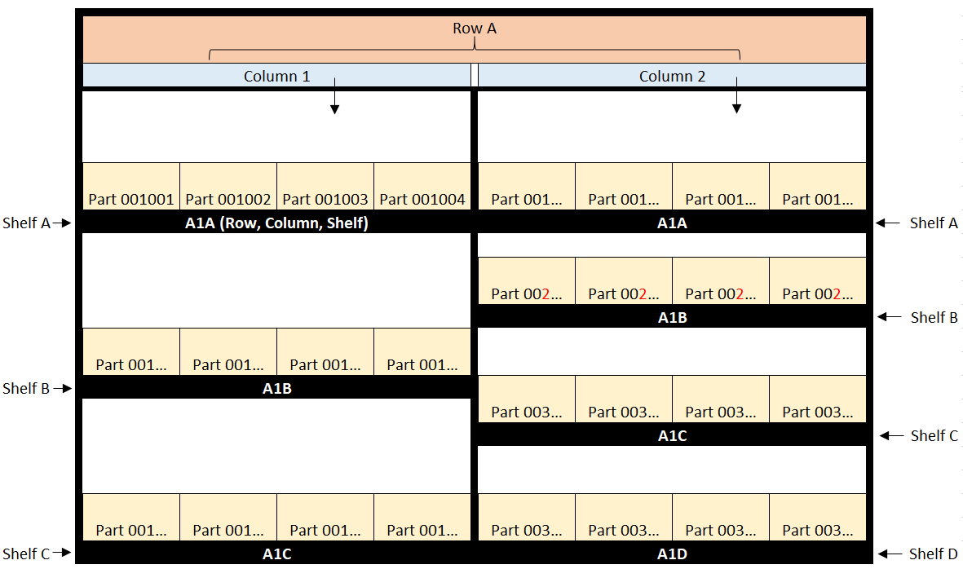

Figure - potential parts shelf layout scheme

## Guidance on inventory timing for dormant parts.

(Jeff Baker) Consensus? Not yet / See notes

Guidance on inventory timing for slow moving / obsolete parts as defined in RP531 involves carefully managing the balance between stocking sufficient quantities to meet potential future demand and minimizing carrying costs associated with slow-moving items. To identify these parts run a slow moving part report at 90 or 180 days in your system (based on your company’s policy), or check dates purchased as some companies will date code part when adding into inventory.  
Once identified as slow moving / obsolete, assess the long-term demand potential for each part based on historical data and market trends. For truly obsolete parts with little to no future demand, consider liquidation or discontinuation to free up valuable storage space and reduce unnecessary holding costs. Effective inventory timing for slow moving parts involves a proactive approach to manage these ~~slow-moving~~ items, aligning stock levels with anticipated demand, and making data-driven decisions to optimize inventory utilization and minimize financial burden.  
Use judgment to determine if the parts in question should in fact be returned. Utilize the Min/Max feature in your fleet's maintenance management system. If you have parts that were once frequently used or have long lead times it may be the proper time to keep a minimum of one part on hand.

## Process for disposing of dormant or obsolete parts.

(Jeff Baker / Josh Oneil) Consensus? Strike – see notes

The process for disposing of dormant or obsolete parts requires careful planning and execution to maximize recovery value and minimize potential environmental impacts. Begin by conducting a thorough assessment of the inventory to identify dormant or obsolete parts, considering factors such as, product life cycles and usage ~~market demand~~. Once identified, categorize the parts based on their condition and potential for salvage or recycling. For dormant parts with the possibility of future demand, consider storage optimization strategies. However, for truly obsolete parts with no viable use, explore options like liquidation through sales, auctions, or partnering with liquidation companies. For environmentally sensitive components, ensure proper disposal methods, such as recycling or hazardous waste processing, in accordance with local regulations. By following a well-defined process for disposing of dormant or obsolete parts, businesses can efficiently manage inventory, recover any remaining value, and uphold responsible environmental practices.  
There may be certain cases when the vendor or supplier may not be able to process the return ~~. Possibly~~ due to the part being special ordered for a specific piece of equipment. ~~I would suggest~~ reaching out to other shop locations and determine if they could possibly utilize the part in question. One strategy would be keep the part in a bin location and in inventory until it hits the slow moving report of 181+ days. At that point, ~~if all else fails~~ you would start the process to scrap the part. ~~A scrap request form could be submitted to your corporate office for authorization to dispose of the part in question.~~

Jeff’s update:

## Process for disposing of ~~dormant~~ or obsolete parts.

The process for disposing of dormant or obsolete parts requires careful planning and execution to maximize recovery value and minimize potential environmental impacts. ~~Begin by conducting a thorough assessment of the inventory to identify dormant or obsolete parts, considering factors such as, product life cycles, and market demand. Once identified, categorize the parts based on their condition and potential for salvage or recycling. For dormant parts with the possibility of future demand, consider storage optimization strategies. However,~~ For truly obsolete parts with no viable use, explore options like liquidation through sales, auctions, or partnering with liquidation companies. For environmentally sensitive components, ensure proper disposal methods, such as recycling or hazardous waste processing, in accordance with local regulations. By following a well-defined process for disposing of ~~dormant~~ or obsolete parts, businesses can efficiently manage inventory, recover any remaining value, and uphold responsible environmental practices.  
There may be certain cases when the vendor or supplier may not be able to process the return. Possibly due to the part being special ordered for a specific piece of equipment~~. I would suggest~~ reaching out to other shop locations and determine if they could possibly utilize the part in question. One strategy would be keep the part in a bin location and in inventory until it hits the slow moving report of 181+ days. At that point, ~~if all else fails~~ you would start the process to scrap the part. A scrap request form could be submitted to your corporate office for authorization to dispose of the part in question.

## Guidance on how to process unused and / or unusable parts in inventory.

(Josh Oneil) Consensus? Strike

~~The first step is to conduct a thorough inventory audit to identify parts that are unused or no longer usable. This process may involve physically inspecting the inventory, reviewing records, and assessing the condition of each item. Once identified, segregate these parts from the rest of the inventory to prevent confusion and avoid accidental use of unusable items.  
The first step is to conduct a thorough inventory audit to identify parts that are unused or no longer usable. It is crucial to maintain detailed records of the entire process. Document the identification, segregation, and disposition steps for each unused or unusable part. Tracking the progress of each part through its disposition process helps ensure that nothing falls through the cracks and provides a clear audit trail for accountability and compliance purposes.  
Accumulating obsolete inventory can occur for several reasons, from inaccurately forecasting demand to a lack of proper inventory management. The most efficient way to identify obsolete inventory is conducting regular inventory audits. Once approved for scrap we may then dispose of the obsolete parts properly. Placing obsolete metal parts in our metal scrap bin or contacting our environmental waste pickup vendor for disposal.~~

## Best practices for handling warranty parts.

(Stuart Doane) Consensus? Yes – based on comment.

Establish a standardized warranty management process that outlines the step-by-step procedure for handling warranty parts. Ensure that your team is well-trained and familiar with the warranty process to handle claims promptly and accurately. Utilize a centralized system or software to track warranty claims, from the initial request to final resolution, to ensure transparency and accountability.

~~By having a well-defined and consistent warranty management process, you can efficiently handle warranty parts, reduce costs, and prevent warranty claim reductions and denials.  
Establish or utilize structured language in repair orders and warranty claims to avoid "unstructured text". Using a centralized system or software and leveraging its use of VMRS or other structured Complaint Codes, Technician Failure Codes, Work accomplished Codes, etc increases the ability to better analyze the data.~~Identify a specific area of the parts room/shelf for warranty parts awaiting disposition (return or discard) from supplier. Parts should be identified clearly in accordance with established policies/processes. Warranty parts should not be disposed of until directed by the supplier.

Establish a schedule to review open warranties for status based on the specific operating environment. Utilize the fleet management system to track all contacts/updates with suppliers until each warranty claim is resolved. Once the warranty claim is resolved, follow an established policy to credit back the costs to the asset.

Leverage the warranty data to identify patterns, trends, and potential issues with specific products or suppliers. Work with suppliers to determine root cause failure analysis of parts to determine if the part, equipment, operating environment, or other factors caused/contributed to the failure in order to reduce the risk of future failures. By studying warranty claims, you can pinpoint recurring problems, determine root causes, and take proactive measures to improve product quality and reliability.

## Best practices for handling core parts

(Stuart Doane) Consensus? Update language – see notes

Develop a robust system for identifying and tracking part cores within your inventory. Each core should be linked to the corresponding new part charged out. For non-reusable cores, such as those damaged beyond repair, have a responsible recycling program in place to dispose of them in an environmentally friendly manner. For additional guidance on effective handling of core parts, refer to RP1615 Parts Core Management for Service Providers.

## Ways to organize inventoried parts using VMRS or other numerical part numbering system.

(TK) Consensus? Yes

~~Start by categorizing your inventory into logical groups based on factors such as item type, size, or usage. Assign a unique numerical code to each category. For instance, if you have different types of screws, bolts, and nuts, you could label screws as "100 series," bolts as "200 series," and nuts as "300 series." Subsequently, assign sequential numbers to individual items within each category. For example, a specific type of screw would be labeled as "101," the first bolt as "201," and so on. This systematic approach enables quick identification and streamlines the organization process.~~

~~Once you've established the numerical system, create clear and consistent labels for each inventoried part. Use durable tags or stickers that prominently display the item's numerical code. Place the labels visibly on each item or its container. If you're using bins or shelves for storage, ensure that the numerical code is also displayed on the respective locations. Consistency in labeling is crucial to avoid confusion and mistakes during the inventory management process.~~

~~Complement the numerical system with a digital inventory management system. Utilize inventory management software that allows you to record and track each part's numerical code along with relevant details such as description, quantity, and location. This digital solution enables real-time updates, making it easier to monitor stock levels, reorder items when needed, and generate comprehensive inventory reports. Furthermore, with the help of barcode scanning technology, you can enhance the speed and accuracy of inventory counting and management.~~

Use a systematic approach to organizing parts to enable quick identification, streamline the organizational process, and minimize errors when handling parts. One way to organize parts in the parts room is by using the VMRS Component Codes – Code Key 31 (Reference RP802F.) Once you've established the numerical system, create clear and consistent labels for each inventoried part. Use durable tags or ~~stickers~~ labels that prominently display the item's numerical code. Place the labels visibly on each item or its container. If you're using bins or shelves for storage, ensure that the numerical code is also displayed on the respective locations. Consistency in labeling is crucial to avoid confusion and mistakes during the inventory management process. Using Barcodes to label parts can aid in accuracy (Reference RP801C).

## Best practices for handling consumable parts.

(TK) Consensus? Yes

~~Implement a systematic consumption monitoring system to track the usage of consumable parts accurately. Regularly reviewing consumption data will help you optimize inventory levels, prevent stockouts, and minimize excess inventory carrying costs.~~

~~Establish strong relationships with reliable vendors and suppliers for your consumable parts.~~

~~Monitor purchases and review dollars spent at least monthly, Maintain adequate stock on hand for shop operation Keep stock in defined locations under supervision, Conduct audits annually—if not more frequently.~~

A method of ensuring that adequate inventory of consumable parts are maintained needs to be implemented. As these items are typically not stocked, counted, and billed as parts; an alternate method of maintaining inventory levels needs to be utilized. Identifying a shelf/shelves for this type of items, and labeling with minimum/maximum quantities and "counting" each week is one way to ensure that there is enough product on hand to meet the needs of the shop. Different Asset Management Software (AMS) may have different methods of "charging" these consumables: Some AMS systems put the consumable parts into inventory via the Purchase Order system, and then charge these consumable parts/supplies to a "shop" Repair Order every month to relieve the inventory, consult with your AMS supplier or help screens to assist in determining the best method for your operation.

## Best practices for parts room cleanliness and proper lighting.

(Chad) Consensus? Not yet

Keeping the parts room clean and organized is essential to prevent damage to inventory items and maintain their quality. Regular cleaning helps eliminate dust, dirt, and debris that can accumulate on stored parts over time. It also reduces the risk of contaminants entering sensitive components. Proper organization ensures that items are stored in designated locations, preventing confusion and minimizing the chances of misplacement. By adhering to cleanliness and organization standards, you can significantly improve inventory accuracy, reduce the need for reorders due to damaged items, and create a more efficient workflow for inventory management.  
 Adequate lighting in the parts room is paramount for ensuring that employees can easily locate, inspect, and handle inventory items. Fixtures should be placed in-between aisles to illuminate the parts on the shelves properly. ~~Each aisle way should have light fixtures that illuminate all of the parts and shelves with minimal shading.~~ Insufficient lighting can lead to errors, delays, and even accidents. Implementing proper lighting solutions, such as overhead lights, task lights, or LED strips, ensures that every corner of the part room is well-lit. This makes it easier for staff to read labels, identify part numbers, and check item conditions. Improved visibility also contributes to a safer working environment, reducing the likelihood of accidents and minimizing the risk of damaged inventory due to mishandling.

Part room cleanliness and proper lighting play a significant role in boosting employee productivity, safety, and efficiency. A clean and organized part room reduces the time spent searching for items, allowing staff to focus on more critical tasks. Clear visibility enables faster identification of parts, streamlining the picking and packing processes safely.

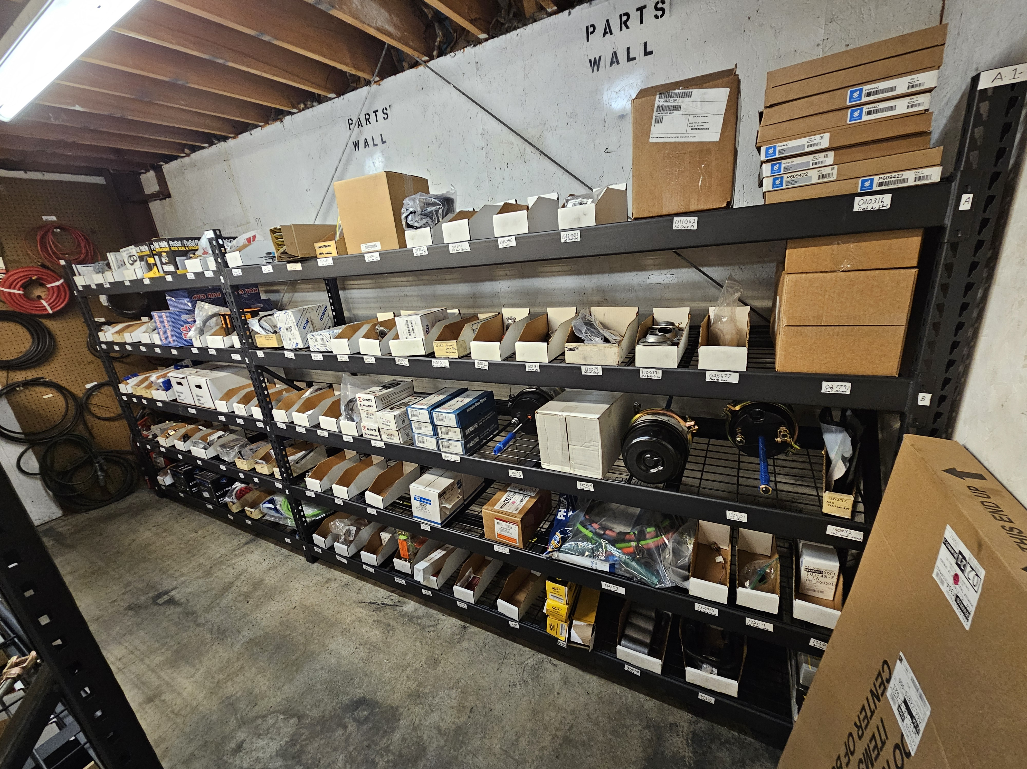

Figure - proper lighting and cleanliness

## Timing for when parts should be charged out of inventory.

(Chad) Consensus? Not yet

The timing for when parts should be charged out of inventory is a critical aspect of efficient inventory management. As soon as a part is used, it should be promptly charged out of the inventory to maintain accurate records and provide real-time visibility into stock levels.  
Inventory should be charged to an asset as it leaves the parts room. Inventory levels in the computerized system should match the physical inventory on the shelves in the parts room reflecting the most current information, reducing the risk of potential discrepancies between physical counts and recorded quantities.   
In a closed parts room, the parts clerk would charge the part to the Repair Order prior to issuing the part to a technician. In an open parts room, the technician should have the ability to enter/scan the part to a Repair Order prior to taking the part from the parts room. Providing a streamlined method for the technician to charge parts minimizes the risk of parts leaving the parts room "unassigned" to a Repair Order.

# Conclusion

*Wayne to write a conclusion statement consistent with other RPs.*

# References

* RP530
* RP531
* RP801C
* RP1603
* RP1605

# RP glossary

*Wayne will create before Spring meeting*

* Dormant part
* VMRS
* Inventory management software system
* Asset Management Software (AMS)
* Repair Order Management system