**TMC Recommended Practice**

**RP 622B VMRS 018-001, -002, -004**

**WHEEL SEAL AND BEARING REMOVAL, INSTALLATION, AND MAINTENANCE**

# PREFACE

The following Recommended Practice is subject to the Disclaimer at the front of TMC's *Recommended Maintenance Practices Manual.* Users are urged to read the Disclaimer before considering adoption of any portion of this Recommended Practice.

# PURPOSE AND SCOPE

This Recommended Practice (RP) defines practices and procedures to perform a wheel seal replacement that meets fleet requirements. This RP sets forth procedures and standards for storage, handling, and installation of wheel seals and wheel bearings for medium and heavy-duty vehicles.

# INTRODUCTION

A wheel end is comprised of as many as six components, each manufactured to within a tolerance of a few thousandths of an inch. These components are assembled in precision fixtures , packed, and delivered ready for use. They make up a system where the performances is dependent on the other components. 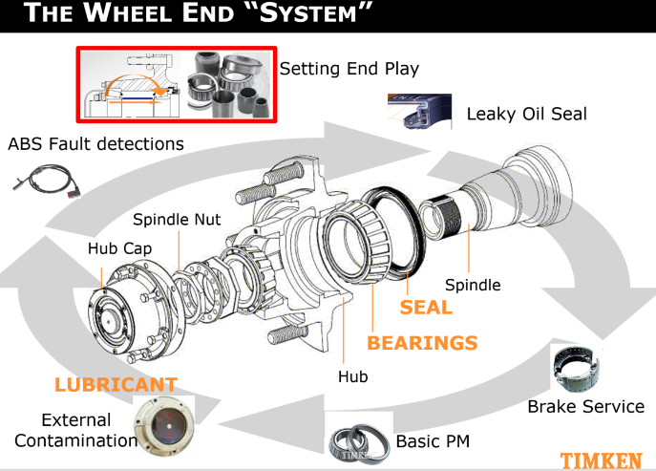 For example, a wheel seal is a precision component, expected to do a demanding job. How it performs depends largely on the conditions of the five mating wheel end components and the care taken during installation.

# WHEEL SEAL AND BEARING HANDLING AND STORAGE

Many wheel seal failures result from improper handling and/or storage of the seals or bearings prior to use. Seals and bearings must be handled with care.

1. Wheel seals should be kept away from electric motors, welding equipment, and all other sources of ozone. Fluorescent light and direct sunlight are also destructive to wheel seals.
2. Store wheel seals and wheel bearings in a clean, dry place. They should not be exposed to extremes of either dryness or dampness.
3. Wheel seals and wheel bearings should be kept in their original factory packaging untiI ready for installation. Never store wheel seals or wheel bearings unprotected in open bins, where they may be exposed to airborne contaminants.
4. Never hang wheel seals and bearings on hooks or nails. Never tag wheel seals or bearings with inventory tags by looping wire through the seal or bearing. These practices will damage the delicate seal lip, the rubber inside diameter (ID) or outside diameter (OD) of the seal, or precision machined bearing surfaces.
5. Keep wheel seals and bearings clean- Avoid laying wheel seals and bearings on a dirty surface.
6. Dropping seals and bearings may cause internal damage which may not be visibly apparent but may be sufficient to impair their efficiency and life expectancy. Seals and bearings which have been dropped should be replaced.

**NOTE:** Never spin a bearing with compressed air gun. This can cause personal injury or introduce contamination.

**WHEEL SEAL AND BEARING REMOVAL AND DISASSEMBLY**

**Wheel Seal Removal**

A pry-bar, crow's foot, or wheel seal puller tool are recommended to remove a seal from the hub. A technician should never remove the wheel seal by driving on the inner bearing cone to remove the wheel seal.

There are two types of spindle mounted wheel seals, a one piece or a two-piece design. The one-piece seal can be removed by driving on the back side of the wheel seal or using a pry bar. The two-piece design will leave the deflector ring on the spindle and the wheel seal will be inside the hub bore. To remove the spindle mounted defector ring, drive the ring over with a ball peen hammer by tapping on the ring to expand the metal and increase in bore diameter.

Never use a sharp tool or chisel to remove the sleeve or deflector ring, because this will damage the spindle shoulder area. It may be necessary to retain the old seal for warranty purposes. Any warranty submitted requires both the deflector ring and the wheel seal to be submitted. For warranty inspections, provide the uncleaned seal in a plastic bag. Always install a new wheel seal whenever the hub has been removed from the spindle. Below is picture of a wheel seal deflector ring that was damaged due to a chisel burr, weld splatter or defect on the spindle shoulder.



deep axial cuts on the ID create

a leak path. Proper inspection and clean-up

of the spindle can eliminate this problem.



Deep axial cuts on the seal OD can also create a

leak path.

# Bearing Race Removal: Iron Hubs

Bearing and race removal should be done with extreme care so that hub bores, bearings, spindles, and housings are not damaged. Follow the hub manufacturer's procedures. A bearing puller or press are helpful to avoid damage. When pullers or presses are not available for cup removal, a soft steel bar should be used to avoid damaging raceways..

**CAUTION[**:Do not use hardened drifts, center punches , or brass bars. They may chip and cause damage or personal injury.

## Bearing Race Removal: Aluminum Hubs

Removal of bearings and cups should be done with extreme care so that hub bores, bearings, spindles, and housings are not damaged. Follow the manufacturer's procedures for removal.

If necessary, in aluminum hubs, remove the race by welding a large continuous bead around the raceway, letting the assembly cool and removing the race/cup. If a welder is not available, heat the hub to 300°F and pound out the bearing cups with a hammer and soft steel bar being careful not to damage the hub. Never use a torch. Inspect the bearing cup bore for evidence of rotation or cup spin. If the cups spun in the hub replace the hub.

**CAUTION[:**Do not exceed 300° F(150°C). Higher temperatures may weaken the material. Do not use acetylene torches or other welding equipment to heat the hub because localized high temperatures may weaken the hub. Hub temperatures can be measured by using a temperature probe such as a thermocouple,, or a Touchless Infrared Thermometer heat gauge. Use the appropriate safety equipment when handling a hot hub to avoid burns.

## Cleaning Wheel Bearings

After removing and reinstalling a bearing, clean it with a petroleum distillate solvent. The solvent should must be clean and filtered. Never use steam or water, they will cause rust in a very short time.

After a bearing has been cleaned, allow it to dry. Avoid using compressed air .

CAUTION: Compressed air can introduce contamination from the air line.

To ensure against contamination, clean all parts coming in contact with, or operating with the bearing. Spray these with clean axle lubricant prior to reassembly. If you are storing the parts, place in protective oil paper or on a dry shop towel.

## PREPARING WHEEL SEALS AND BEARINGS FOR INSTALLATION

Refer to **Fig. 1,** for a diagram of a properly installed wheel seal and related components. Correct installation of oil seals ensures maximum sealing and service life. There are four key points to assure proper installation and performance:

1. The hub bore and spindle must be prepared to receive the seal.
2. The seal must be prepared for installation using the manufacturer’s instructions.
3. The seal must be properly installed using tools designed for the purpose.
4. Bearing end play must be properly adjusted and verified.

The contact surfaces where the new seal will be installed must be free from rust, scale, old sealant, nicks, burrs, and any roughness. Clean surfaces with a wire brush or emery cloth. Avoid scratching the hub or seal bore. When cleaning aluminum hubs, use non-metallic scrapers to prevent damage.

## Inspecting and Preparing the Hub Bore

1. Inspect the bore into which the seal fits for nicks or gouges that could cause leakage. Sharp corners can score the seal OD and cause leakage.
2. Remove any rust, scale, sealant, and roughness with a wire brush. Then use fine

emery or crocus cloth for final cleaning. If there are any deep grooves, fill them in with a hardening gasket material. Redress the filled area with emery or crocus cloth.

1. Sharp edges on the bore entrance should be chamfered or rounded off with a small file, then carefully smoothed with an abrasive cloth.
2. Thoroughly clean and dry the entire area. Make certain it is completely free of dirt, grit, chips, or other abrasives which score, damage, cut, or damage the seal's outer surface and cause leakage.
3. Be sure all lubricant is removed from the hub cavity. Wipe the cavity clean using a clean, dry cloth.
4. In the event of wheel bearing failure or severe contamination (by sand, grit, water, metal etc.), the hub should be thoroughly cleaned and refilled with clean lubricant.

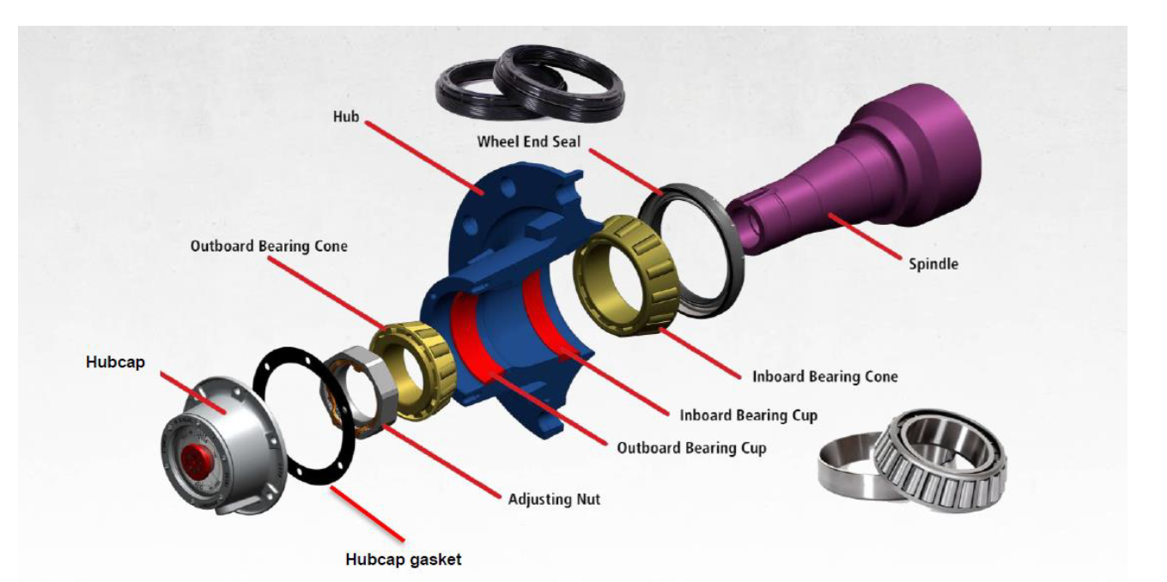

**Fig. 1: An Installed Wheel Seal**

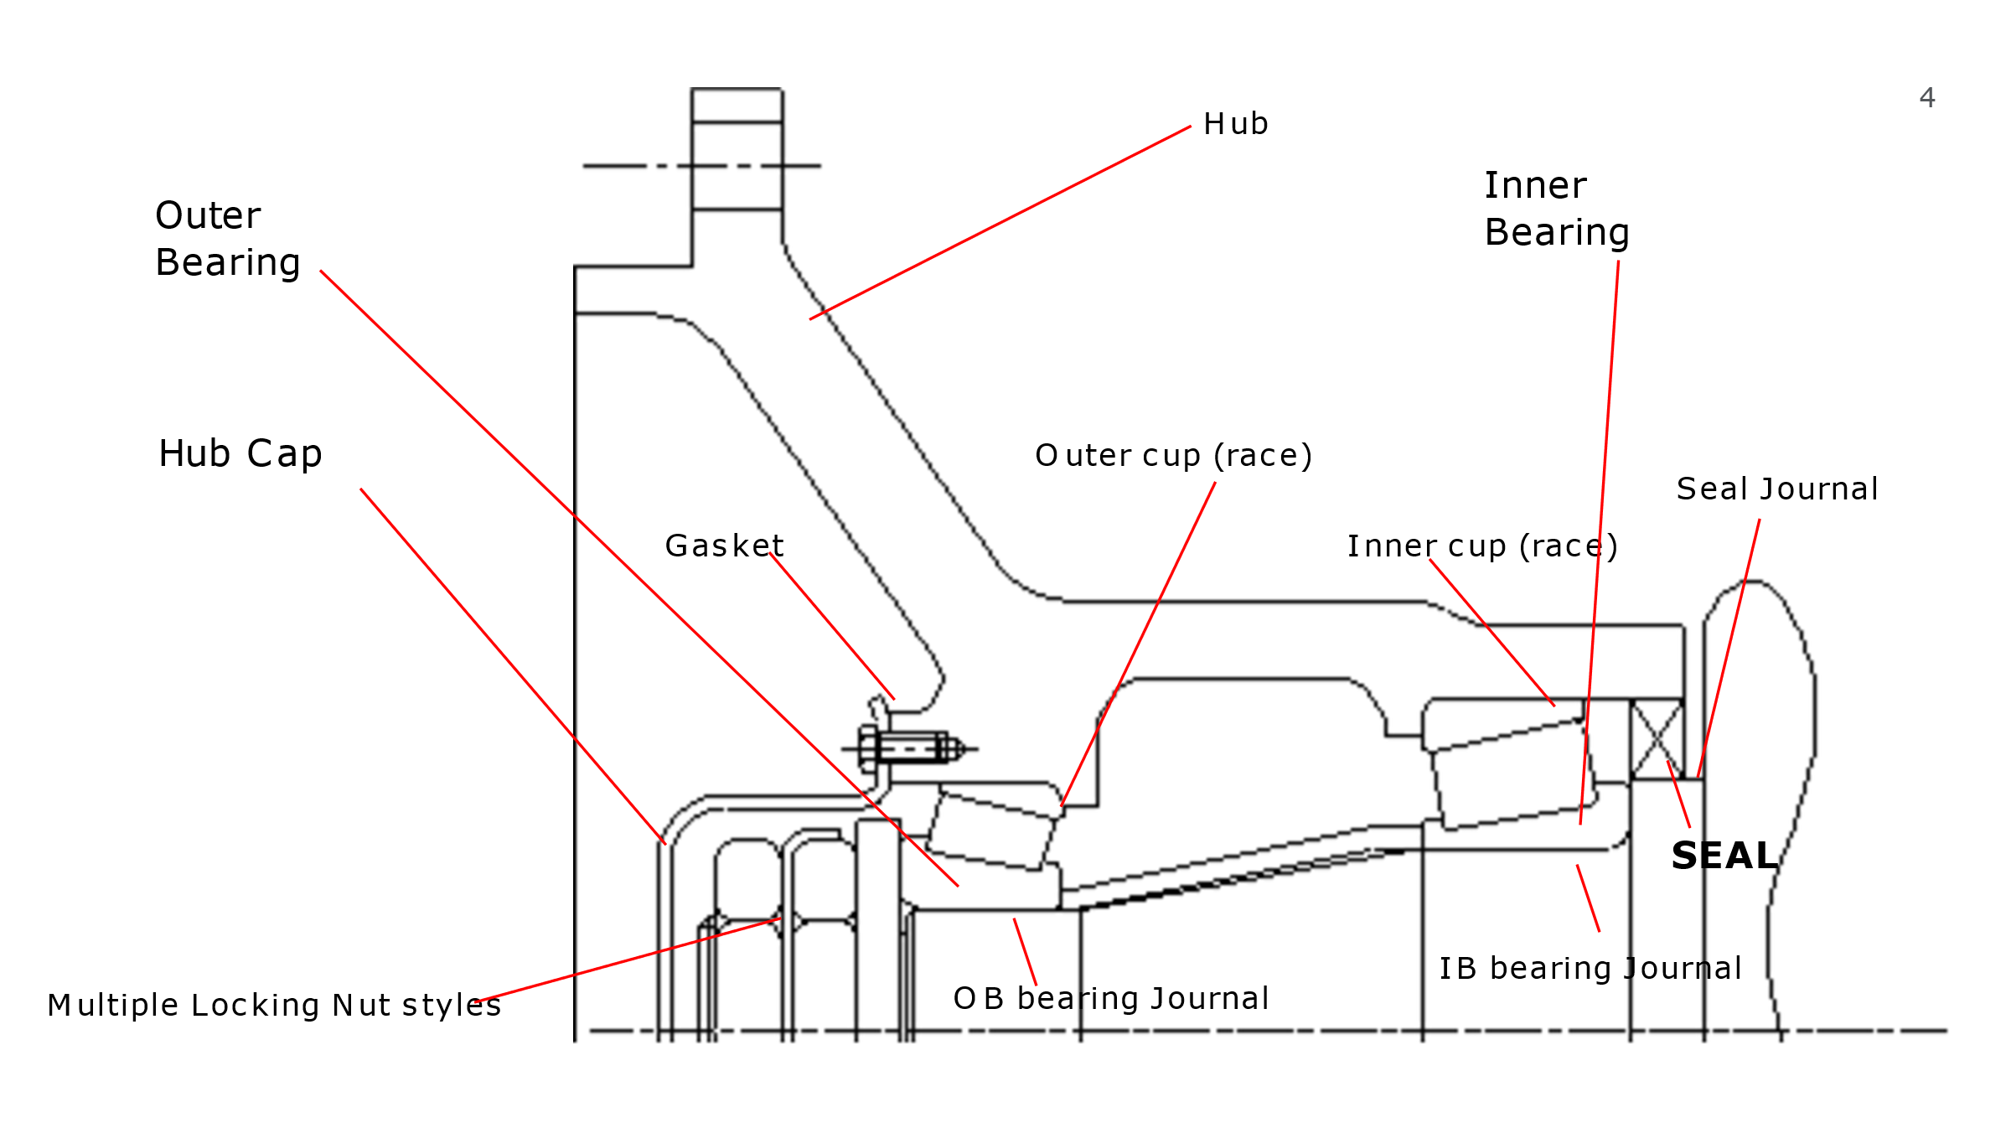

# Inspecting and Preparing the Spindle

1. Thoroughly clean the spindle with solvent and a clean, dry shop rag, then examine the spindle for flaws.
2. Remove any rust, old sealant, and roughness from the entire length of the seal journal. Use a wire brush and crocus cloth to polish the spindle seal journal area with appropriate solvent. Use a wire brush, emery cloth as appropriate. Be sure to clean the seal journal back at least 5/8” – ¾” because some seals ride further back than others. Be careful not to damage the seal journal while using the appropriate cleaning tools..
3. CAUTION: : Improper use of power tools can damage the seal riding surfaces

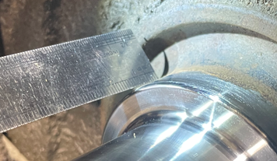

1. Clean all threads and keyways thoroughly with a wire brush to enable proper bearing adjustment. Minimize any contaminants in the lubricant cavity.
2. Use caution to remove sharp edges on the lead-in chamfer
3. Wipe the entire spindle surface with a clean, dry cloth, making certain the spindle is completely free of dirt, grit, chips, or other abrasives which could damage the seal's inner surface and cause oil leakage. Clean all threads and keyways. Apply a thin coat of #2 non-hardening sealant to the axle shoulder when installing a wheel seal with a deflector ring or wear ring. A very small amount of the sealant is required, and it should never be applied to the I.D. of the wheel seal deflector ring or wear ring.

# Bearing Inspection

A bearing that has been removed should be cleaned with solvent. Steam or water will rust bearings, thus should never be used.

Bearings that are rusted, flaked, pitted, or have dam aged cages should be replaced. It is wise to replace all questionable bearings and always replace the cup and cone as a matched set. Never reassemble a tapered roller bearing in a damaged or worn housing or on damaged or worn spindles.

Housings and spindles should not be re-machined if the bearing journal is worn. Spindle wear is typically caused due the inner bearing journal spinning on the axle journal. The inner bearing journal is designed to slowly rotate on the spindle to allow even race wear. Bearing journal wear can be an issue on older equipment, if the bearings were improperly adjusted too tight, or if the axle was overloaded, or experienced lube breakdown. When spindle wear becomes excessive, it will lead to premature wheel seal failures, bearing failure, irregular tire wear, and brake related issues due the journal wear.

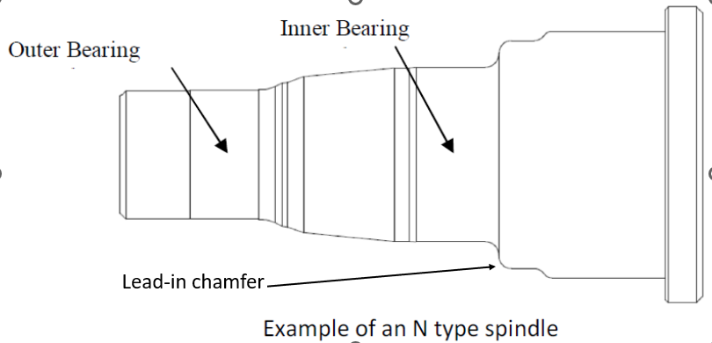

NOTE: The condition of the hub lubricant can be an indicator of spindle wear. If metal particles are present in the lube, pay additional attention to the spindle journals.

Contact the original equipment manufacturer (OEM) / axle supplier if wear is present.

After bearings have been cleaned, inspect both the cups and cones for color change on the bearing surface.

Bearings should be silver in color. Any other color is a concern. See below. The normal operating temperature in a wheel end is 50-80 Degrees (F) hotter than ambient temperature of oil lubed hubs. Grease wheel ends can run 20-30 Degrees hotter than oil.

All iron oxidizes have different colors depending on temperature. This can be used as a “crude” thermometer. The color progression from cool to hot is: straw to brown to purple to darkening blue to dark blue to light blue to gray. This corresponds to about 450 degrees F for straw to about 650-degree F for light blue/gray.

|  |  |
| --- | --- |
| **Degrees Fahrenheit** | **Colors for Tempering** |
| 450 | Pale straw-yellow |
| 490 | Yellow-brown |
| 500 | Brown-yellow |
| 520 | Brown-purple |
| 540 | Full purple |
| 550 | Dark purple |
| 560 | Full blue |
| 570 | Dark blue |

After inspecting the cleaned bearing, spray with axle lubricant. If you are not re-installing the bearings immediately wrap in clean oil paper.

Replacement bearings should be stored in a clean, dry place and should not be removed from their car­ tons until ready for use. There is no need to remove the rust preventive coating from new bearings upon installation.

After a new bearing has been removed from the carton and wrapper, it should be immediately installed on the vehicle. Never place bearings on a floor or a dirty workbench, or in a dirty wash tank. Do not leave them exposed in open trays, pans, or cabinets where dirt, dust, and moisture can reach them.

## Preparing the Seal for Installation

1. Examine the new seal for evidence of damage or handling damage.
2. Some seals are lubricated before packaging to prevent rusting or oxidation during storage. Do not remove this factory lubrication. Other seals may require lubrication before installation. Follow the seal manufacturer's recommendation. If lubrication is needed, use a light film of the same type of wheel end lubricant used in the hub being serviced.

## Bearing Cup Installation: Iron Hubs

If a bearing race/cup has to be replaced, be careful not to create burrs or damage the cup or cup seats. Cup seats should be inspected for burrs or nicks and repaired to ensure bearings seat properly. If the hub bore is scored or damaged, the hub should be replaced. Proper drivers should be used to install cups to prevent bearing damage. The hub bore should provide a press fit. Use a 0.001" to 0.002" feeler gauge to ensure the cup is fully seated against the shoulder of the bearing bore. Avoid misalignment to assure against premature bearing or seal issues. Misalignment is a popular cause for bearing and seal issues.

**Bearing Cup Installation: Aluminum Hubs** Clean and inspect the bearing bore and cup seat. Remove nicks, burrs, and foreign material. If the bore is scored or damaged, the hub should be replaced. The hub bore should provide a press fit.

To install a new cup in an aluminum hub, TMC recommends that the hub be heated evenly throughout in an oven at 175-205°F. Hub temperatures can be checked by using a temperature probe or touchless Infrared Thermometer. To ease assembly, the cup may also be chilled. Cooling the cup in a freezer to 32°F or below will ease the installation. CAUTION: NEVER COOL BELOW -65°F. Install the new bearing cup being certain it is fully seated. It may be necessary to tap the cup with an installation tool or a soft steel bar and a mallet to fully seat it. If the cup is loose, allow a few seconds for it to normalize with the hub temperature. Use a 0.001" - 0.002" feeler gauge to ensure the cup is fully seated against the hub shoulder.

## WHEEL SEAL AND BEARING INSTALLATION PROCEDURES

**NOTE:** Follow manufacturers' installation procedures. Always use a bearing cup and cone from the same manufacturer replacing them as a set. This assures the internal geometries match and improve hub performance and minimize seal leaks.

After the bore, spindle, seal, wear ring (where applicable), and bearing have been examined and prepared , the wheel seal is ready for installation.

Recommendations on installation tools and procedures vary among different wheel seal manufacturers, so be sure to use only installation tools and procedures recommended and approved by the wheel seal manufacturer.

**NOTE:** All pre-lubrication must be done using the same lubricant that will be used in service unless the wheel seal is pre-lubed at the factory.

## Hub-Mounted Wheel Seal: Tool Installation

1. Place the hub assembly flat or at least at a 45° angle for seal installation.
2. Select the correct tool handle, adapter plate, and bearing pilot for the seal being installed. Tool identification information is printed on most manufacturers' packages or in catalogs. Pre-lube the inner bearing cone with clean lubricant used in the hub and place it in the hub. Place the seal on the tool with the air side facing the adapter plate or place the seal onto the hub bore and insert the tool assembly into the seal depending on the seal manufacturer instructions.

Using a 3-5 pound hammer, Hold the tool straight and drive the seal with firm hammer strokes until the seal is squarely seated. Ensure that the inner bearing rotates freely. Lubricate the ID of seal with clean lubricant.

**NOTE:** If the seal uses a separate Deflector ring or wear sleeve, install it on the spindle as follows:

1. Apply a thin coat of #2 non-hardening sealant to the axle shoulder when installing the deflector ring or wear ring. A **very small amount** of the sealant is required, and it should never be applied to the I.D. of the wheel seal deflector ring or wear ring. 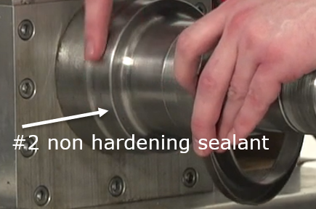
2. Place the deflector ring or wear sleeve on the spindle shoulder.
3. Select the proper tool and drive the sleeve in place with a 3–5-pound hammer. Check that it is completely on the spindle and the edge is square with the shoulder within

0.005 inches.

d. Wipe off any excess sealant that squeezed past the deflector ring on the oil side of the spindle.

# Hub-Mounted Wheel Seal: Hand Installation

* 1. Lightly lubricate the seal ID and OD evenly with lubricant. Also apply a thin film of lubricant on the hub bore that is to receive the seal. Never install the seal without lubricant.
  2. Hand press the seal evenly into the bore. A rubber mallet or other soft-faced tool, if recommended by the manufacturer, may be used to gently tap the seal into place. Apply an even driving force to avoid cocking the seal or damaging the flange surface. Be sure that the seal is evenly seated and bottomed in the bore.

**Spindle Mounted Wheel Seal Tool Installation:**

Review the seal manufactures specification on adding a non-hardening sealant to the spindle before installing the seal on the spindle. Some wheel seal manufactures recommend a light coating of #2 sealant to seal up minor imperfections on the spindle journal.

1. Place the seal on the spindle so that it has begun to seat on the seal journal with the "oil side" marking out.
2. Select the correct installation tool supplied by the manufacturer. *Do not* install seals without the correct tools and/or adapters (where applicable).
3. Place the correct driving tool in place and drive the seal until the tool bottoms out with a 3–5-pound hammer. Rotate the tool and repeat to ensure proper seal location.
4. Remove the driving tool and inspect the seal to ensure that it is square 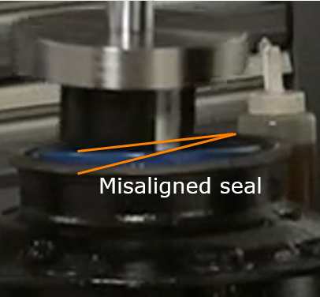and bottomed out within 0.005" on the spindle shoulder. Do not proceed until the seal is flush with the hub & spindle shoulder. See examples of seal misaligment) 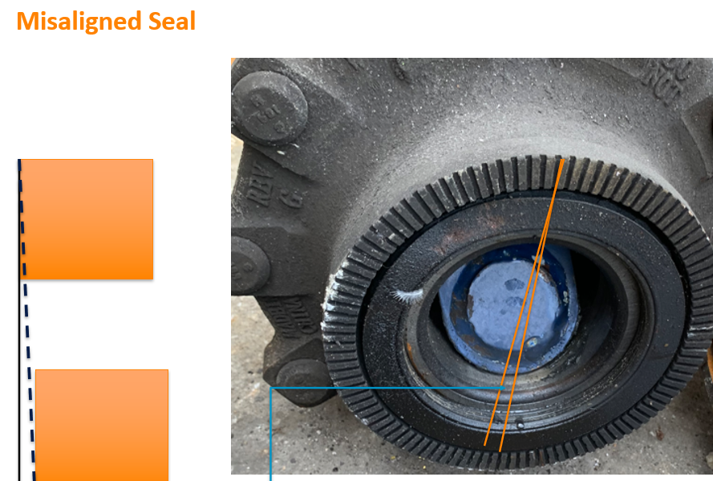
5. Pre-lubricate the inner bearing with the same lubricant used in the hub and insert it onto the spindle.

**Caution:** In oil bath hubs, do not pack the wheel bearings with grease. This will inhibit oil circulation. This is especially critical in drive axles.

**Relubrication and final assembly:**

1. The axle must be level. Tire and wheel assembly should be removed from the wheel end before final assembly. Care should be taken to avoid contacting the spindle end during the assembly process. Caution must be exercised when installing the seal over keyways or threads.
2. Fill the hub cavity with clean oil when using a hub installed wheel seal. When using a spindle installed wheel seal it is best to wait until the seal is pulled into the hub bore to add oil to the hub. **This step is mandatory for proper bearing and seal performance.** Applyclean oil to the outer bearing and place it in the hub. Inspect the threads of the adjusting nuts and hand tighten the spindle nut.

**CAUTION:** Assure wheel bearings are properly set (See RP 618) Wheel bearing adjustment affects wheel seal life, wheel bearing life, and the life of tires. The first indication of excessive wheel end play is wheel seal leakage.

Wheel ends with manually adjusted bearings require a minimum of 0.001" to a maximum of 0.005" end play for adequate seal and bearing performance. Performance improves as endplay decreases to 0.001". Compliance with end play requirements are verified with a calibrated dial indicator on every wheel end. Specific torquing procedures to achieve the end play tolerances are documented and available from the individual axle, bearing and seal suppliers.

For hubs with Pre-adjusted and Unitized wheel bearings, follow the manufactures product specific installation instructions.

**NOTE:** Never use an impact wrench to adjust wheel bearings an tighten spindle nuts.

4a. **For steer and trailer axles only­** Install the hub cap using a new gasket and fill with clean oil to the proper level. Allow time for the lubricant to pass through the outer bearing before rechecking to verify the final oil level. Hub cap bolts should be torqued to the hub cap manufacturer's recommended torque specification in a star pattern. Check the hub cap vent plug to make certain the vent hole is clean. Reinsert the plug.

4b. **For drive axles only-** Reinstall the axle shaft

using a new gasket or gasket material. Torque the nuts to the manufacturer's specifications. If wheel hubs are equipped with oil fill/drain plugs, add a quart of oil to each wheel end. For hubs without fill plugs, it is required to top off the rear axle housing with the proper amount of lubricant, and then articulate the axle.

**Axle Articulation Procedure:**

add one quart to the fill plug, articulate axle for 5 minutes per side.

jack up each side of the drive axle a minimum of eight inches for two to three minutes to move the lubricant into the opposite wheel end through the axle tube.

Recheck the main sump for the proper oil level and top off the lubricant level if required. Make certain the main axle sump is filled to the proper level such that the oil escapes by slightly seeping from the drive fill plug hole.



**Caution:** Failure to articulate a drive axle as noted above will result in a premature / Catastrophic bearing failure

Weight 5 minutes before checking oil level. (Ref RP655 for lubricating suggestions)

**NOTE:** Plugged axle breather or vent will lead to a premature wheel seal failure.

# Hub Fill Procedures: Semi-fluid Grease

If tires are not mounted, install the hub on the spindle. Take care to not damage the seal. Use lifting equipment to align the hub assembly with the spindle, taking care to not damage the seal and spindle threads, and push the hub assembly into position. With the hub supported, before installing the outer bearing cone, begin filling from the bottom of the hub cavity. Top-off by placing the pump nozzle above the spindle and continue pumping grease into the hub cavity. The grease fill amount should be to a 3 and 9 O'clock level. This represents 50 percent hub cavity fill. Some hub manufacturers have a fill plug in the barrel of the hub and have established a recommended fill volume for semi-fluid grease, specific to their hubs. Be sure to follow the manufacturer's fill procedure for the hub you are installing.

**NOTE:** A template may be used to hold the lubricant in place while filling the hub cavity. Refer to RP 631C for an example of a template.

# LUBRICATION

Correctly lubricate wheel seals and bearings in accordance with OEM recommendations. Improper lubricant level could cause severe wheel end damage. Do not mix lubricants.

# REFERENCES

* TMC RP 618C, *Wheel Bearing Adjustment Procedures* provides information on the proper method of wheel end installation and adjustment.
* TMC RP 624B, *Lubrication Fundamentals* pro­ vides information on lubricant Fundamentals which should be reviewed before selecting wheel end lubricants.
* TMC RP 631C, *Guidelines for Wheel End Lubrication* discusses lubricant considerations for wheel end applications.
* TMC RP 640C, *Alternate Wheel Bearing Adjustment Systems* describes specialized wheel end systems which are alternatives to the conventional systems discussed in RP 618B.
* TMC RP 644A, *Wheel End Conditions Analysis Guide* offers guidelines on how to detect wheel end conditions and evaluate wheel end service­ ability.