Extracted content from withdrawn proposal for CONTROLLED AREA NETWORK (CAN) BUS TROUBLESHOOTING

This document is intended to provide guidance to assist in troubleshooting controller area network (CAN) databus networks on medium- and heavy-duty commercial vehicles. It provides a baseline method- ology for CAN bus troubleshooting in both a simple setup (direct physical access to a CAN bus) and troubleshooting through a vehicle gateway module electronic control module (ECM). This RP applies to Class 7-8 vehicles used in commercial applications.

NOTE: The use of “RP 1210-compliant” triage applications, including “freeware” applications available to the industry as of this writing. All of the commonly utilized triage applications are able to utilize a vehicle diagnostic adapter (VDA) that complies with the criteria established in TMC RP 1210D, Windows Communication Application Program Interface (API). In accordance with the disclaimer listed at the beginning of TMC’s Recom- mended Practices Manual, this document does not constitute an endorsment of any specific company or application.

COMMON CAN BUS DIAGNOSTIC ISSUES
CAN bus failures frequently occur because of the harsh environments in which equipment must op- erate, including commercial vehicle on-highway, off-highway, industrial-stationary, and agricultural applications. This RP discusses troubleshooting CAN bus electrical failures with an emphasis on these industries. The following sections describe some of the more common issues with CAN databuses used on commercial vehicles and equipment.

Water/Moisture Intrusion
It is almost impossible to prevent water intrusion when a wiring harness runs outside of the vehicle or equip-
ment. However, the issue is not just water intrusion, but corrosive chemicals brought in with the water like ice and snow melting agents. The water intrusion happens at a microscopic level and “wicking” draws moisture and chemicals into the wire. With years of harsh service, this can result in corrosion and open circuits, even though there is no visible damage to the wire’s sheathing. Within a wiring harness, water intrusion can also create shorts and open circuits. To minimize such risk, technicians should:
- always inspect suspected wiring harness con- nection points for signs of corrosion, and;
- never use probes that depend on piercing insulation to make electrical contact. If used, make sure to properly seal the wire or con- nector afterward.

Mechanical Vibration
Long-term vibration can create issues with wiring, especially where the wiring enters a connector, or is tied to the chassis. Vibratory chafing inside of a wiring harness can also cause intermittent shorts/grounds. To minimize such risk, technicians should inspect suspected wiring harness for a very tight bend radius and for signs that “zip-ties” may have broken through the protective plastic harness tubing and damaged sheathing.

Connectors at the ECM
Other issues that are hard to troubleshoot occur at ECM connectors. Sometimes these connections are so tightly packed that the pins in the connectors pull out of their cavities, causing intermittent open circuits. This is especially true if the weight of the harness pulls on the connector and vibrates. This not only affects databus connections, but can also affect sensors or other inputs/outputs to/from the ECM.
To minimize such risk, technicians should inspect suspected wiring harness at the ECM connection to ensure they are not stressed.

Aftermarket ECM Additions Adding Termination Resistors (Telematics)
A CAN network has two 120 ohm termination resistors at the physical “ends” of the network (see Figure 1).

© 2024—TMC/ATA

Issued x/xxxx

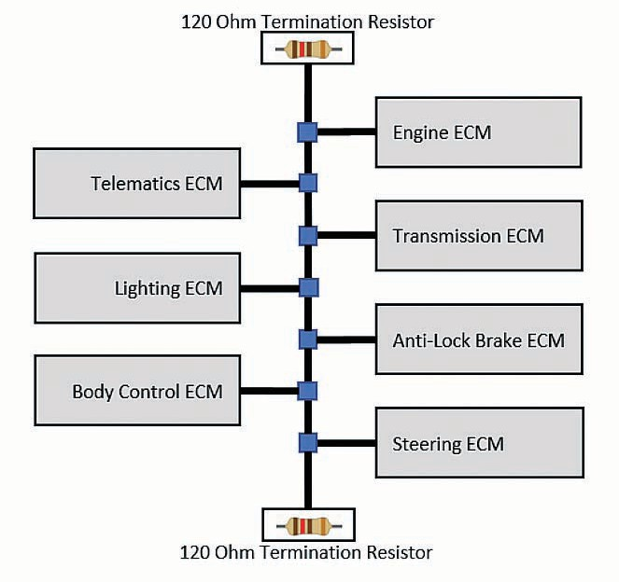
Figure 1 illustrates an example of a properly termi- nated CAN databus.

Figure 2 illustrates an example of an improperly
terminated CAN databus.

For information on repairing and splicing into the SAE J1939/CAN databus, see TMC RP 1226B, Vehicle Accessory Connector Guidelines, or the SAE J1939- 15 Appendices.

Figure 1: Properly Terminated CAN Bus
Some technicians install aftermarket ECMs such as electronic logging devices (ELDs) behind the diag- nostic connector by butt-splicing or Scotch-locking into power, ground, and SAE J1939/CAN databus lines. Although installations have improved over the years, some installers have added an unnecessary terminating resistor (see Figure 2). To rectify this situation, most original equipment manufacturers (OEMs) now provide TMC RP 1226 specified connec- tors and most telematics/ELD providers now provide TMC RP 1226 specified harnesses.

Some fleets disconnect third-party devices before connecting to the vehicle to run diagnostic applica- tions. Sometimes this helps solve the “ECM A cannot communicate with ECM B” scenarios. If a vehicle generates databus-related diagnostic trouble codes (DTCs) after a telematics or other ECM installation, this may be the cause.
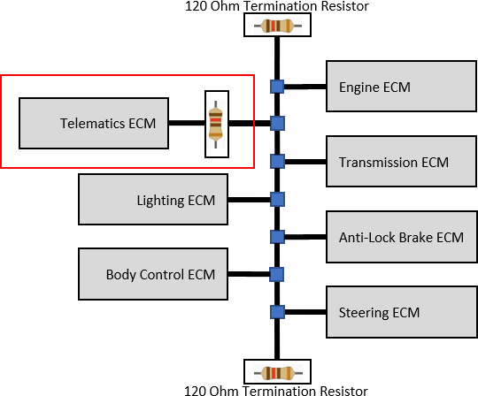
Figure 2: Improperly Terminated CAN Bus

DIAGNOSING THROUGH CAN BUS GATEWAYS
For most vehicles and equipment, long gone are the days when a single CAN bus or totally separate CAN buses can be connected individually. Most vehicles have more two or more CAN networks, and some of these networks are gatewayed to other networks. A gateway module (or gateway functionality in an existing ECM) adds an extra layer of complexity.

This section describes issues that can happen on a CAN-bus system with a gateway installed between two ECM networks. The two individual CAN network segments should be treated as “independent” CAN buses as far as troubleshooting is concerned. The PC-based and electrical troubleshooting defined in this document should be performed, along with troubleshooting wire faults, on each separate seg- ment. Some OEM diagnostic applications provide instructions that tell the technician which possible network segments need to be investigated.

Here are a few tips for troubleshooting a gateway network system:
- Leave any gateway modules connected when doing initial troubleshooting. A necessary ter- minating resistor may be inside the gateway module(s).

See Gateway Hardware and Firmware Pos- sibilities.

Gateway Hardware and Firmware Possibilities The following steps discuss when to remove a har- ness from an ECM:

Step 1: Gateways have electronic components in- ternally connecting the two CAN buses. There are two separate CAN transceivers and at least one microprocessor controlling them.

Step 2: Gateway modules include software/firmware that reads messages from one CAN link, potentially acts upon the messages to perform a function, and then potentially sends the message to another CAN

TABLE 1. CAN TRANSCIEVER TESTING
Value | Issue | Next Step/Resolution
1-4 MΩ | No Issue | Refer to OEM Literature
< 1 MΩ | Faulty Transceiver | Replace ECM

link. There could be a bug in the software/firmware causing issues if the buses are fine electrically.

Step 3: Gateway devices do not always send a mes- sage out for every message received. Gateways are usually intelligent devices that can be programmed to “throttle” output from one bus to another. This helps keep down on high bus utilization on the output data bus. For example, engine speed may be read on the powertrain bus every five milliseconds; however, it may only be gatewayed to the telematics bus every 250 milliseconds.

Step 4: A gateway device is most likely handling more than just two databuses. This can create issues where the gateway is so inundated with messages from one databus that it “gets behind” in handling messages to/from other databuses.

Step 5: Some ECMs were programmed as if their “partner ECMs” were on the same databus. Of note:
- These ECMs may not get an expected mes- sage on time and then send communication DTCs like “Intermittent CAN Bus Problems” or “Issues Communicating with ECM X.”
- These DTCs are intermittent because while a vehicle is in motion, the databus utilization increases.
  - At rest with the key-on-engine-on there is not a problem.
  - In a key-on-vehicle-moving scenario the problem pops back up.

- Microprocessors have gotten faster, but data- bus speeds and the number of databuses have also increased. If there are intermittent issues and both networks are fine electrically, it could be either an issue with the gateway ECM hardware (unlikely) or the gateway is having a hard time keeping up.

Other Steps to Implicate the Gateway Module Step 6: If both network segments check out, check the CAN transceivers on both CAN channels of the gateway. Damage to one or both CAN transceiver circuits may increase the leakage current in the circuit. To measure current leakage through CAN circuits
the technician will be required to remove the ECMs from the vehicle and will need the manufacturer’s pin-out diagrams to locate the CAN_Hi, CAN_Lo, and Ground pins for that ECM. To do so:
- Remove the ECM from the vehicle. Refer to OEM literature.
- With the VOM set to read resistance (Ohms setting), place one lead on the CAN_Hi ter- minal and the other lead on the CAN_Ground terminal. Note the value.
- With the VOM set to read resistance (Ohms setting), place one lead on the CAN_Lo ter- minal and the other lead on the CAN_Ground pin. Note the value.
- Compare both values to Table 1.

Step 7: If possible, replace the gateway and see if that resolves the issue.

Step 8: Check with the OEM to see if there is a soft- ware update that needs to be applied, or if they have heard of this specific issue in the specific vehicle or equipment being used.

CAN BUS TROUBLESHOOTING
- Troubleshooting Software for Windows Before utilizing a volt/ohm meter (VOM) as defined below in Part B: CAN Bus Physical Troubleshoot- ing Using a Volt/Ohm Meter, the best first approach is to use a VDA and a simple Windows™-based troubleshooting application. This can save a lot of time by helping identify issues on a CAN network segment.
There are several freeware RP 1210-compliant ap- plications that can help determine if communications can be established with the vehicle and what ECMs exist on that vehicle or equipment. These applications will do the following:
  - Check if a network is active “at all”, and at what CAN baud rate the network is running. A newly added device can cause issues if it connects to the CAN bus at the wrong speed.
  - Help diagnose whether a VDA is working properly. Many CAN failures are discovered doing routine diagnostic work. A bad VDA or VDA cable can appear to be a vehicle network

issue (no connectivity). Use another VDA, VDA cable, or VDA USB cable.

Help diagnose a VDA’s connector and cable (broken wires or pins pushed back).
  - Can be used to get a list of ECMs transmit- ting. Some CAN networks use 11-bit CANIDs for addresses while others use parts of the 29-bit CANID. Many OBDII systems use 11-bit CANIDs for addresses. Other OBDII systems and J1939 uses Byte 0 of the 29-bit CANID for addresses.

Check for ECMs that have dropped from the network due to a CAN BUS_OFF scenario. They do this by:
    - Getting a list of ECMs (i.e., J1939 ECMs) immediately after a key-on cycle.
    - Waiting 10 seconds, re-scan, then compare with the first list to identify an ECM that has “dropped off.”

Most VDA vendors have a well-documented Windows™-based test tool. There are also various freeware applications on the internet, some that are RP 1210 and SAE J2534 compliant and work for light-duty through heavy-duty vehicles and equip- ment. Simply do an internet search for “RP 1210 VDA validation tool” or “SAE J2534 VDA validation tool.”

Most of these applications will help you through the first level of troubleshooting, which is to establish some level of communications with the vehicle and/ or a specific ECM. If the application you were using for this step indicates further diagnosis of the vehicle because of a missing ECM, an ECM appearing then disappearing (going BUS_OFF), or no communica- tions at all, please follow the steps in the next several chapters on physically/electrically troubleshooting the CAN bus.
Some CAN networks are not brought out to a con- nector that can be readily accessed like the J1939 nine-pin, the OBDII/J1962, or RP 1226 connector. On these networks, the technician needs to be careful about where they plug in to do troubleshooting. If possible, do not use probes that depend on piercing the insulating sheath to make electrical contact (see Water/Moisture Intrusion).
- If piercing probes were needed in an area at risk of moisture intrusion, the technician should waterproof where the probes were inserted. Always refer to OEM documentation on places to connect to do databus troubleshooting.
- If back-probing a connector, be careful not to damage the wiring or the socket, it may pull back.

Can Bus Physical Troubleshooting Using a Volt/Ohm Meter
Pinouts for the most common connectors are listed in the Common Industry Connectors section. If con- necting to a different connector or to a CAN databus not brought to a connector, refer to the OEMs drawing to locate the CAN channels and wiring. The follow- ing seven-step procedures are the same either way.

Step 1: Check for Proper Termination Resistance
- Remove the positive battery lead from the battery.
  - This step cannot be omitted. There may be active ECMs on the databus even in a key-off position.
  - If the vehicle has a battery disconnect, that by itself is not good enough. Other connections to the positive battery terminal may exist that power up the databus in a key-off position.

- With the VOM set to read resistance (ohms set- ting), place one lead on the CAN_Hi terminal and the

TABLE 2: TERMINATION RESISTANCE CHECK
Value | Issue | Next Step/Resolution
54-66Ω | No Issue | Go to Step 2: Shorts to Ground.
> 120Ω | Any reading above 66Ω is suspect.  Possibly an open circuit or only one terminat- ing resistor (120Ω or more).  Possibly missing a terminating resistor (>130Ω implies this). | Wire trace for a possible open or missing ter- minating resistors. Refer to OEM literature for terminating resistor placements.
<44Ω | Possibly more than two terminating resis- tors.  Possibly wires shorted together in harness. | First, Wire trace for possible extra terminating resistors at the logical ends of the network. Refer to OEM literature for terminating resistor place- ments.Then wire trace for a possible short.

TABLE 3: SHORTS TO CROUND CHECK
Value | Issue | Next Step/Resolution
< 10kΩ | No Issue | Go to Step 3: Shorts to Battery Voltage.
> 10kΩ | Wire is shorted to ground. | Wire trace for a possible short.

other lead on the CAN_Lo terminal of the diagnostic connector (or anywhere on the vehicle network).
- Compare to the Table 2.

Step 2: Check for Shorts to Ground
- Ensure the positive battery lead is still removed from the battery.
  - This step cannot be omitted. There may be active ECMs on the databus even in a key-off position.
  - If the vehicle has a battery disconnect, that by itself is not good enough. Other connections to the positive battery terminal may exist that power up the databus in a key-off position.

- With the VOM set to read resistance (ohms set- ting), place one lead on the CAN_Hi terminal and the other lead on the Ground terminal. Note the value.

- With the VOM set to read resistance (ohms set- ting), place one lead on the CAN_Lo terminal and the other lead on the Ground. Note the value.

- Compare each value to Table 3.

Step 3: Check for Shorts to Battery Voltage
- Ensure the positive battery lead is still removed from the battery.
  - This step cannot be omitted. There may be active ECMs on the databus even in a key- off position.
  - If the vehicle has a battery disconnect, that by itself is not good enough. Other connections to the positive battery terminal may exist that power up the databus in a key-off position.

- With the VOM set to read resistance (Ohms set- ting), place one lead on the CAN_Hi terminal and the other lead on the battery positive lead that was just removed. Note the value.
  - If there was more than one lead connected to the battery plus terminal, connect them all electrically and then connect the lead. One of the extra wires may have been the power for the module.

- With the VOM set to read resistance (Ohms set- ting), place one lead on the CAN_Lo terminal and the other lead on the positive lead that was just removed. Note the value.
  - If there was more than one lead connected to the battery plus terminal, connect them all electrically and then connect the lead. One of the extra wires may have been the power for the module.

- Compare each value to Table 4.

Step 4: Check for Proper CAN Voltage

NOTE: Most VOM or multimeters analyze voltage on a Root Mean Squared (RMS) basis. With the pulsing of the CAN databus (2.5V +/- 1V) the typical voltage oscillates/hovers around three volts.

- Replace the positive battery lead and power the vehicle.

- Place the key switch in the on/accessory position.

- With the VOM set to read DC Voltage, place one lead on the CAN_Hi terminal and the other lead on the Ground terminal. Note the value.

- With the VOM set to read DC Voltage, place one lead on the CAN_Lo terminal and the other lead on the Ground terminal. Note the value.

- Compare each value to the Table 5.

TABLE 4: SHORTS TO BATTERY VOLTAGE CHECK
Value | Issue | Next Step/Resolution
< 10kΩ | No Issue | Go to Step 4: Proper CAN Voltage.
> 10kΩ | Wire is shorted to ground. | Wire trace for a possible short.

TABLE 5: CAN VOLTAGE CHECK
Value | Issue | Next Step/Resolution
2-4V | No issue. CAN network appears operational. | First, try Step 5: Ensure the ECM Has Connectiv- ity to the Databus (Stub Connection).  Then troubleshoot ECMs by connecting to the net- work through a VDA and PC-based software. See CAN Bus Troubleshooting Step : Troubleshoot- ing Software for Windows.
<2V | Possibly one or more faulty CAN transceivers. | Go to Step 5 or refer to OEM documentation.
>2V | Possibly one or more faulty CAN transceivers. | Go to Step 5 or refer to OEM documentation.

Step 5: Ensure the ECM Has Connectivity to the Databus (Stub Connection)
Before removing the ECM from the vehicle (see Step 6), this is a good way to eliminate the ECM as the root cause.

- Ensure the positive battery lead is removed from the battery.
  - This step cannot be omitted. There may be active ECMs on the databus even in a key-off position.
  - If the vehicle has a battery disconnect, that by itself is not good enough. Other connections to the positive battery terminal may exist that power up the databus in a key-off position.

- Remove the ECM connector from the ECM.

- With the VOM set to read resistance (ohms set- ting), place one lead on the CAN_Hi terminal and the other lead on the CAN_Lo terminal on the ECM side of the connector.
  - Do not probe from the back of the connector (the pins/receptacles may have “pulled back”).

- Compare both values to Table 6.

Step 6: CAN Transceiver Testing
Damage to one or both CAN transceiver circuits may increase the leakage current in the circuit.

To measure current leakage through CAN circuits, it is required to remove the ECMs from the vehicle and the technician will need the manufacturer’s pin- out diagrams to locate the CAN_Hi, CAN_Lo, and Ground pins for that ECM.

- Remove the ECM from the vehicle. Refer to OEM literature.

- With the VOM set to read resistance (ohms setting), place one lead on the CAN_Hi terminal and the other lead on the CAN_Ground terminal. Note the value.

TABLE 5: ECM CONNECTIVITY CHECK
Value | Issue | Next Step/Resolution
44-66Ω | No Issue. | ECM wiring to the databus is good.  Go to Step 6: CAN Transceiver Testing.
> 10kΩ | ECM not connected to main databus. | A pin may be pulled back, or a wire is broken from the connector to the main databus.  Restart test from back of connector to eliminate pin/socket “pull back” issues.  If no connection from front and back of connector, begin wire tracing. See Individual Wire Tracing.

TABLE 7: CAN TRANSCIEVER TESTING
Value | Issue | Next Step/Resolution
1-4 MΩ | No Issue | Refer to OEM Literature
< 1 MΩ | Faulty Transceiver | Replace ECM

- With the VOM set to read resistance (Ohms set- ting), place one lead on the CAN_Lo terminal and the other lead on the CAN_Ground pin. Note the value.

- Compare both values to Table 7.

INDIVIDUAL WIRE TRACING
Individual wire tracing for continuity and shorts in- volves many skill sets, especially when a databus is involved. These skill sets extensive practice to master. These skills involve:
  - Learning where to find OEM wiring diagrams in OEM documentation or in diagnostic ap- plications.
  - Learning how to trace individual wires from connector pin to connector pin.
  - How to spot and fix pin/socket “pull backs.”
  - Becoming proficient in the use of the VOM in detecting shorts and opens without compro- mising wire integrity.
  - Learning to repair wires without inducing added resistance/impedance, and ensuring the repair is waterproof.

There are several good electrical troubleshoot- ing reference books available. One such book for beginning technicians is Fundamental Electrical Troubleshooting by Dan Sullivan, available through various online sources.

After using the Windows™-based PC troubleshooting tool and checking the databus for correct termination/ shorts/voltages, the final step is wire tracing. The beginning steps of wire trace troubleshooting are:
- Obtaining the correct wiring diagram.

- Finding the databus (electrical) circuit you are looking for and the wiring harness(es) it is in.

- Finding the connectors, connector locations, wire segments, and pins for the databus wires in the connector. See Appendix I for common connector types. The list usually includes wire number, and color, harness, connector(s), and pin/plug information on the connectors.
- Removing power from the vehicle by disconnecting the positive terminal from the battery.
  - If the vehicle has a battery disconnect, that by itself is not good enough. Other connections to the positive battery terminal may exist that power up the databus.
  - It is easier to troubleshoot this way and there is less chance to induce shorts or grounds.

- Checking all wire segments identified in Step 3
for continuity, shorts to ground, or shorts to voltage.
  - Printing any wiring documentation allows marking what segments have been tested.
- Repairing compromised wire segments without compromising integrity of the wire, connector, or vehicle databus.

See continuity definitions in Table 8.

TABLE 8: CONTINUITY DEFINITIONS
Term | Value Range
Continuity Between Wire Points | < 10Ω
Short To Ground or Power | < 10Ω
Open Between Wire Points | > 10Ω

Example of Point-To-Point Wire Tracing
This example describes tracing wires in a simple single-CAN-bus system with no gateway modules. The DTC encountered might be: “Engine ECM – No communications with Transmission ECM”

- You try a Windows™-based test tool and notice that the transmission ECM is never seen on the databus, however the engine ECM can be seen.

- You also go through the electrical troubleshooting and find:
  - A correct reading of about 60Ω between CAN_Hi and CAN_Lo.
  - The CAN bus voltage is correct at around
+three volts RMS.
  - This leads you to believe that the databus backbone is intact.

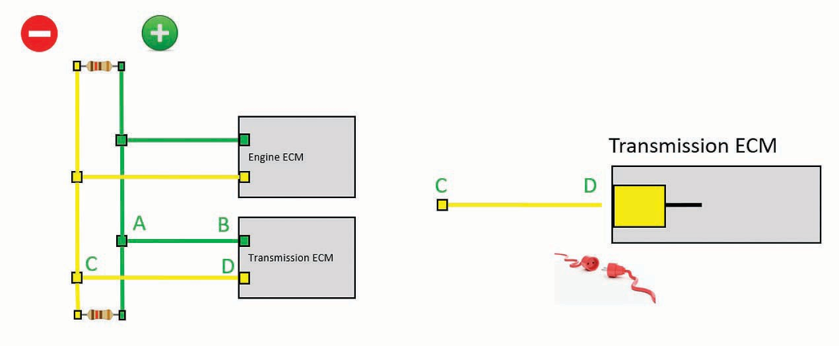

Figure 3: WIre Tracing Example

  - Now begin looking at the possibility of a broken wire somewhere between the transmission ECM and the databus, or that the transmission ECM itself may be faulty.

- In Step 5 – Ensure the ECM Has Connectivity to the Databus (Stub Connection) the technician removed the wiring harness connector from the ECM and found that there is an open circuit.

As illustrated in Figure 3:
- Check the connection from A-B (CAN_Lo) from the inside of the connector and find continuity.
– No need to check the connection from A-B from the outside of the connector cavity.
- Check the connection from C-D (CAN_Hi) from the inside of the connector cavity.
  - There is an open circuit indicated.
- Check the connection from C-D from the out- side of the connector to find is has continuity.
  - There is a problem between with the con- nector to the ECM.
  - Look at the connector to find that the con- nector socket is corroded and replace it. After you replace the socket, you ensure that the repair is waterproofed if needed.

APPENDIX I
COMMON CAN BUS CONNECTORS
TMC provides this listing as to assist in identifying common connected types used in the industry as of the development of this RP. TMC does not recommend any manufacturer or product. Future revisions of this RP will endeavor to provide updates to this information.

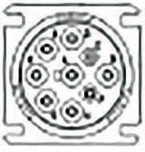
- J1939 9-PIN DEUTSCH TYPE I (HD VEHICLES PRIOR TO 2016)
Grey or Black

Pin | J1939 Standard | FTL Cascadia | PACCAR <=2009
A | Ground | Ground | Ground
B | Power | Power | Power
C | CAN1, J1939+ | CAN1, J1939+ | CAN1, J1939+
D | CAN1, J1939- | CAN1, J1939- | CAN1, J1939-
E | CAN1, J1939 Shield | CAN1, J1939 Shield | CAN1, J1939 Shield
F | J1708/J1587+ | J1708/J1587+ | J1708/J1587+
G | J1708/J1587- | J1708/J1587- | J1708/J1587-
H | OEM Specific | CAN2+ | Spare
J | OEM Specific | CAN2- | ISO9141 K-Line

Pin | 1939 Standard | FTL Cascadia | PACCAR <=2009
A | Ground | Ground | Ground
B | Power | Power | Power
C | CAN1, J1939+ | CAN1, J1939+ | CAN1, J1939+
D | CAN1, J1939- | CAN1, J1939- | CAN1, J1939-
E | CAN1, J1939 Shield | CAN1, J1939 Shield | CAN1, J1939 Shield
F | J1708/J1587+ | J1708/J1587+ | J1708/J1587+
G | J1708/J1587- | J1708/J1587- | J1708/J1587-
H | OEM Specific | CAN2+ | Spare
J | OEM Specific | CAN2- | ISO9141 K-Line

- J1939 9-PIN DEUTSCH CONNECTOR TYPE II (HD VEHICLES 2016+)

Lime Green

Pin | 1939 Standard | PACCAR 2016+ | NAVISTAR
A | Ground | Ground | Ground
B | Power | Power | Power
C | CAN1, J1939+ | CAN1, J1939+ | CAN1, J1939+
D | CAN1, J1939- | CAN1, J1939- | CAN1, J1939-
E | CAN1, J1939 Shield | CAN1, J1939 Shield | CAN1, J1939 Shield
F | J1708/J1587+ or CAN3+ | CAN3+ | J1708/J1587+
G | J1708/J1587- or CAN3- | CAN3- | J1708/J1587-
H | OEM Specific | CAN2+ | CAN2+
J | OEM Specific | CAN2- | CAN2-

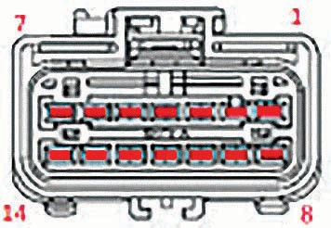
- TMC RP 1226 TELEMATICS/ACCESSORY CONNECTOR

OEM Side Plug

Pin | J1939 Standard | PACCAR 2016+ | NAVISTAR
A | Ground | Ground | Ground
B | Power | Power | Power
C | CAN1, J1939+ | CAN1, J1939+ | CAN1, J1939+
D | CAN1, J1939- | CAN1, J1939- | CAN1, J1939-
E | CAN1, J1939 Shield | CAN1, J1939 Shield | CAN1, J1939 Shield
F | J1708/J1587+ or CAN3+ | CAN3+ | J1708/J1587+
G | J1708/J1587- or CAN3- | CAN3- | J1708/J1587-
H | OEM Specific | CAN2+ | CAN2+
J | OEM Specific | CAN2- | CAN2-

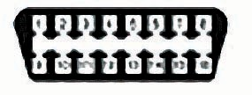
- SAE J1962/OBDII CONNECTOR (AUTOMOTIVE, MEDIUM-DUTY, VOLVO 2013+)
Black

Pin | J1962/OBDII Standard | Volvo 2013+ | GMC Topkick/Kodiak Isuzu F-Series
1
2 | J1850VPW+ / J1850PWM + |  | J1850 VPW+
3 | CAN2+ | CAN2/J1939+
4 | Chassis Ground |  | Ground
5 | Signal Ground | Ground | Signal Ground
6 | CAN1/ISO15765+ | CAN1/ISO15765+ | GMLAN+
7 | ISO9141/ISO14230 K-Line |  | J1708/J1587+
8
9
10 | J1850VPW- / J1850PWM-
11 | CAN2- | CAN2/J1939-
12 | CAN3+ | J1708/J1587+
13 | CAN3- | J1708/J1587-
14 | CAN1/ISO15765- | CAN1/ISO15765- | GMLAN-
15 | ISO9141/ISO14230 K-Line |  | J1708/J1587+
16 | Power | Power | Power

