S.16 - Electrical Vehicle Shop Bay Planning

Preface
The following Recommended Practice is subject to the Disclaimer at the front of TMC’s Recommended Maintenance Practices Manual. Users are urged to read the Disclaimer before considering adoption of any portion of this Recommended Practice.

Users should also review and consult with local Occupational Safety and Health Administration (OSHA) guidelines and/or local authorities having jurisdiction before implementing the following practices covered in this document.

Purpose and Scope

The purpose of this Recommended Practice is to provide a comprehensive and standardized framework for service providers and fleets, empowering them with the essential understanding of minimal shop bay arrangement and planning recommendations to facilitate Battery Electric Vehicles. This ensures easy access to necessary tools and infrastructure is prioritized while integrating safety protocols*.

The adherence to this recommended practice intended to provide improved efficiency, reduced downtime, and enhanced safety. The recommended practices provided in this document align with current industry standards and will be regularly updated to reflect advancements in Battery Electric Vehicle technology and the industry’s best practices.

When implementing RP 16XX, Reference
- RP 16XX, Service Provider Safety Aspects for Battery Electric Vehicles

Introduction
As the commercial truck industry accelerates toward a sustainable future, Battery Electric Vehicles (BEV) are at the forefront of this transformation journey. Their increasing prevalence demands a comprehensive grasp of the infrastructure and facility prerequisites essential for efficient BEV servicing. In response to this industry shift, this Recommended Practice offers a standardized framework for understanding BEV facility requirements. Whether you’re a service provider or part of a fleet, this document equips you with the knowledge needed to seamlessly facilitate BEV repairs.
Disclaimer: This Recommended Practice serves as a valuable resource for service providers and fleets working on battery electric vehicles (BEVs). However, it is important to note that this Recommended Practice does not supersede any guidelines, policies, or instructions set forth by the respective company, manufacturer, or any other relevant authority. It is essential to adhere to the specific guidelines provided by your organization or the manufacturer when performing any service event on a BEV. This Recommended Practice is intended to complement and enhance existing guidelines, emphasizing the importance of safety throughout the service process.

Infrastructure/ Shop Layout
The proposed Infrastructure and Shop Layout Standardization aims to provide a consistent framework applicable to both existing shop facilities and newly constructed ones. While retrofitting an existing shop facility may necessitate additional effort and adjustments to align with the recommendations, it is imperative to fully implement all suggested guidelines. Doing so ensures that Battery Electric Vehicle (BEV) servicing can be efficiently carried out.

Pre-check and installation requirements for implementing a BEV Service Bay:

- Charger Implementation
  - The following steps are suggested to perform before ordering a charger, it is important to do a pre-check inspection of the building to check if the building is capable to handle the charging loads. *
    - Request quotation for an installation from the supplier of the charger or certified facility electrician and include following information in the request.
      - Building Drawings.
      - Electric Circuit Diagrams for the site installation – with proposed positioning of chargers (If preferred positions exist) or information on where vehicles need to be charged.
      - Data on currently available power/grid connection and power usage.
    - A supplier of the charger should provide the required information to their installation company/partner best suited for the task.
      - All charger inter-operability confirmed by the OEM or other brands that the service shop will be servicing.
    - Installer should investigate the procedure to adapt facility and install equipment.
      - A quotation for the installation can be based solely on information provided in the request for installation quote. If the information inadequate a quotation for an onsite pre-check inspection by the installer should be provided.
    - An installation quotation is provided.
    - Ordering of installation is done either through the supplier of the charger or to the installation partner involved, in accordance with local agreements.
  - Dependent on the OEM and Charging supplier will differ, but it is imperative that you also work with your local power company and contractor (if applicable to the project).
  - If applicable; for the mobile charger It is important to map out where in the building it is possible to connect the charger, this is very important in the cases where more than one charger is used in the same circuit breaker.
  - It is recommended to have a charger located in the designated Service Bay to Increase support of both diagnostics and service of the vehicle. This should be a separate charger than what is used to charge customer vehicles.

*Note: Pre-check inspection is recommended to be ordered as a first step in the BEV service bay planning for an existing or new building. This is helpful where an evaluation of several buildings is required before a decision is made for charging strategy. Local law and regulations must be considered.

- Ceiling Height requirements
  - Minimum 18 ft. in height for lifting a BEV vehicle safely or what is appropriate for the vehicle.
  - Ensuring that the space above the vehicle is free and clear of obstruction.

- It is preferred to have a designated Battery Service Area within the Shop
  - This should be located within the EV Service Bay or in proximity for EV component work or internal battery work when required or authorized by your OE.
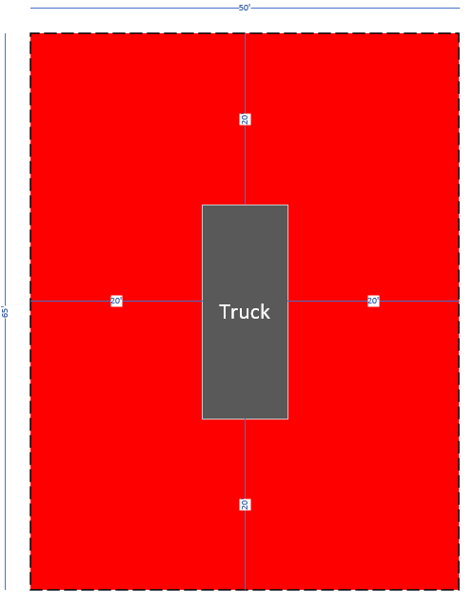
- Emergency Battery Container Safety zone, some examples of these safety zones include:
  - A minimum distance of 20ft. from any building, component, or vehicle
  - On a non-flammable surface such as asphalt, concrete, or concrete paving blocks.
  - It is still important to review with local laws and regulations before final plans are implemented to ensure you are following your local authority having jurisdiction.
- Other bay location considerations:
  - Proximity to wash bay.
  - Proximity to charging equipment for charge validation.
  - Proximity to entry and exit doors for quick removal of vehicle incase of emergency.

Bay configuration:
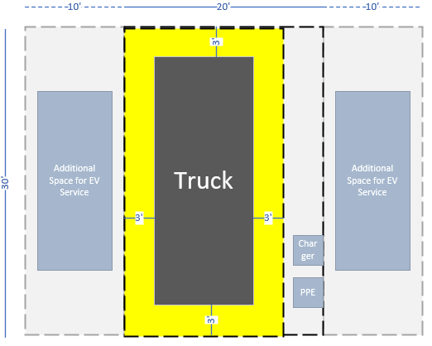
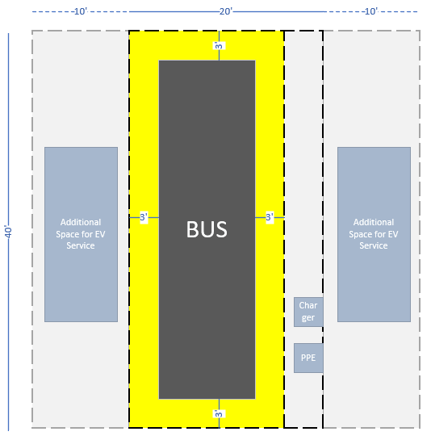

Dedicated BEV Bay minimum requirements:
- Clean and area free of oil and other contaminants
- Ability to access all sides of the vehicle due accommodate different battery configurations.
- Ability to remove a vehicle form the bay safely and quickly in an emergency/rapid removal.
- Designated area outside service shop for vehicle that has been evacuated.
- Quality / condition of bay environment – not cluttered/ clean.
  - Ensure that workshop equipment is also secured such as handling equipment, cables and pipes above workspace, separating walls and other peripheral equipment around the workspace is kept clean on a regular basis.

Safety equipment & essential BEV tools in proximity to service bay:

- Equipment located in or around bay.
  - Charger
    - Recommended to have a stationary charger located in the bay to be used for both diagnostics and service of BEV’s.
    - If a stationary charger cannot be implemented, you must have the ability to have a mobile charger in the BEV bay.
  - PPE
    - Shepherds hook
    - Lockout Tag out box and equipment dedicated to bay and configured for EV vehicles.
      - Lockout Tag Out Box should be large enough to contain all battery fuses and MSD’s.
    - Other Electrical Safety equipment, when applicable
      - Gloves
      - Glove Inflators
      - Mat for working on vehicle while lying on the ground.
  - Signage identifying inside of the service bay or quarantined area.
    - BEV Safety Barrier Clearance zone around vehicle – it references space around the vehicle and not specific distance. Generally acceptable space around vehicle is 3 feet. Shown in yellow in charts 2 and 3 above.
    - Properly identifies and informs personnel / first responders of the type of vehicle in for repair.
    - Examples of information on signs are:
      - Work on energized or live circuits, e.g., batteries
      - Name of who is responsible for the work on the vehicle or battery.
      - Inform on the cleanliness of the work area.
      - Inform unauthorized personnel to keep out.
      - Danger-High Voltage
    - For examples of exact signage that relates to Safety in working with High Voltage reference your local OSHA guidelines. – insert quick link
  - Signage identifying outside of the service bay or quarantined area.
    - When a vehicle is in the workshop, apply signs on the work bay door(s). This is to inform the local first responders in case of accident.

- Equipment Recommended in or near Service Bay
  - First Aid Equipment
    - Defibrillator
  - Designated tooling specific for BEV Servicing vehicles only (i.e., HVAC recovery tool, 4 Wheel Vehicle Lifts). This will be described in greater detail below.
  - Designated Work Bench in Service Bay for High Voltage Electric work
    - Equipped with rubber safety mat with Class 4 rating.
- Battery repair area
  - Reference OEM specifications related to battery repair area as each OEM may have different requirements.
  - Should not be located next area where grinding or potential contaminants may enter the workspace.
  - Should follow minimum requirements set forth for BEV Service Bay.

BEV Specific Tooling

Some examples based on OEM guidelines include, but are not limited to:

- Tooling and maintenance/inspection protocols for tools.
- Lock Out Tag Out equipment. (For reference on procedure and practice, reference RP543)
- Vehicle lifts (For reference in properly lifting of vehicles, review RP1618)
  - Ensure that lifts appropriate for the equipment that will be serviced is installed.
    - Some manufacturers require four-corner post lifts that can lift a total of 56,000 to 64,000 pounds (each post lift being capable of lifting 14,000 to 16,000 pounds)
- Battery Pack Repair-reference OEM guidelines if applicable.
- Storage and moving of batteries (i.e., composite pallets, storage location) separate from service bay.
- Battery specific lifting equipment and designated table or platform that can handle weight and servicing.
- Insulated tools.
- Proper Personal Protective Equipment (PPE) should be onsite. Reference RP 16XX for PPE recommended practices.

Bay Management & Compliance

Upon establishing a dedicated Battery Electric Vehicle (BEV) service bay, it is advisable to maintain a comprehensive inventory of all tools and equipment specific to the BEV service bay. This should be accompanied by safety protocols and illustrative diagrams.

The facility should ensure there is adherence to local Occupational Safety and Health Administration (OSHA) guidelines and/or local authorities having jurisdiction.

It is paramount during the safe inspection and validation of the functionality and condition of these tools and equipment that there is a scheduled review and standard documentation of these findings, on a regular scheduled basis (at least a monthly basis). For any non-compliant items, it is imperative that the noncompliance items found are taken care of before any servicing of any vehicles.

The recommended practices have been provided as guidance for those who are interested in having a BEV service bay within an existing facility or a new construction. As stated in this document, it is imperative to review your local and state guidelines for safety, construction, and in combination with the OEM of the vehicles and the included tools for service.

