TMC Recommended Practice
RP322B VMRS 042-004

COOLANT PUMP FAILURE MODES AND LIFE EXTENSION
PREFACE
The following Recommended Practice is subject to the Disclaimer at the front of TMCs Recommended Maintenance Practices Manual. Users are urged to read the Disclaimer before considering adoption of any portion of the Recommended Practice.
PURPOSE AND SCOPE
This Recommended Practice (RP) lists the most common modes of coolant pump failure and their potential causes. It also offers recommendations for extending coolant pump life. It does not offer guidelines for coolant pump design.
This RP contains information derived from:
  - A fleet survey conducted by TMC’s Coolant Pump Failure Task Force,
  - TMC Task Force presentations and:
  - Service bulletins from various original equipment manufacturers (OEMs) and suppliers
This RP applies to coolant pumps used on light and heavy-duty trucks and truck tractors.

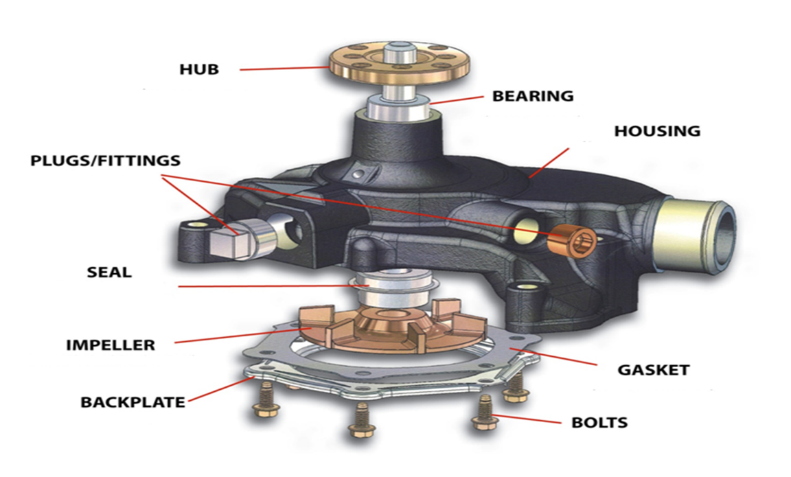

COOLANT PUMP FAILURE MODES
There are (nine???) seven main types of coolant pump failures:

- Cavitation.
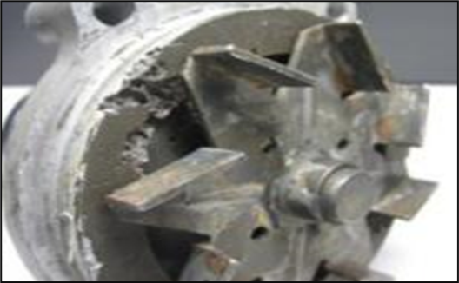
Cavitation is a process caused by the presence of air in a low-pressure area, such as occurs on the trailing surfaces of coolant pump impeller vanes. Flashing (a rapid evaporation of liquids) may also occur alongside cavitation. Conditions causing cavitation-related failures are:
  - Over-speeding of the coolant pump due to engine over-speed or incorrect drive/driven pulley selection
  - Incorrect or faulty radiator pressure cap
  - Low concentration of antifreeze or no antifreeze in the coolant
  - Low level of supplemental coolant additives (SCAs).
NOTE: Conditions (c) and (d) cause the loss of metal surface protection provided by chemicals in antifreeze and SCAs. This allows corrosion and mechanical pitting to occur.

- Erosion.

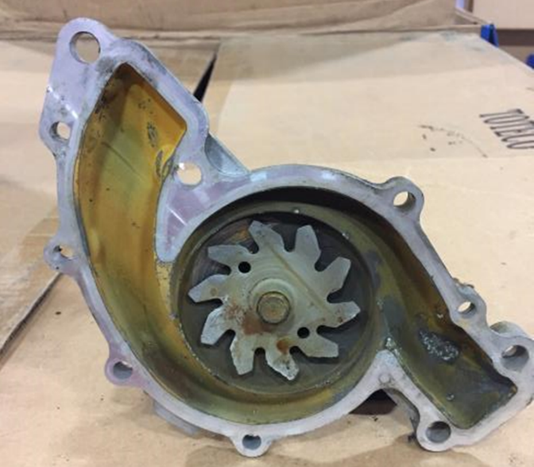

Erosion occurs when abrasives or foreign matter physically wear away at surfaces. Erosion generally occurs on cast-iron coolant (pictured is an aluminum pump) pump impeller tips. Lack of cooling system filtration, outside contamination (water source), and manufacturing process residues (such as core sand) all contribute to erosion failure.

- Coolant Pump Seal Failures.

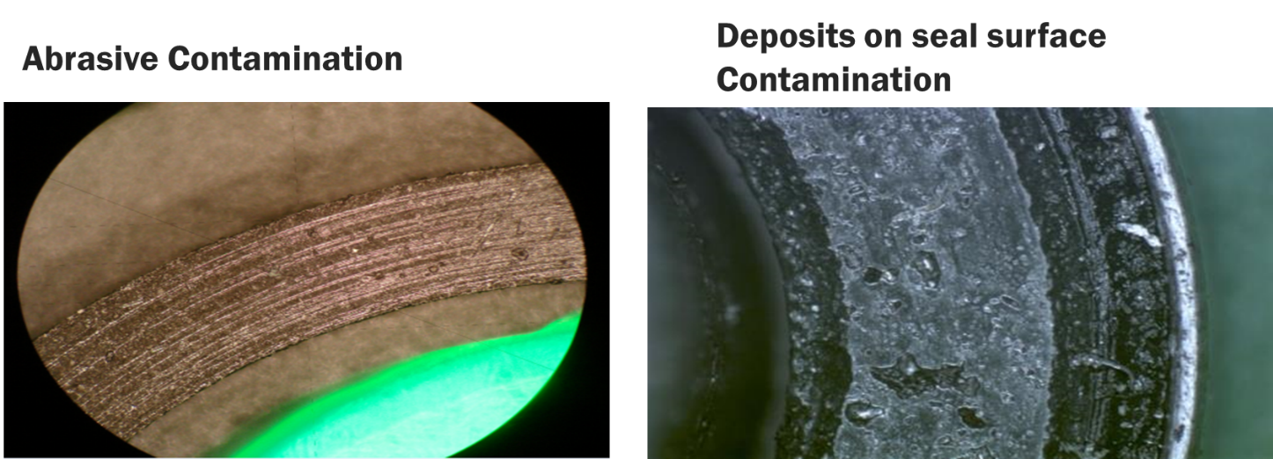

All coolant pump face-type seals require a liquid film to lubricate and cool seal surfaces. Excess coolant chemicals, undissolved solids, make-up water with high mineral content or high-silicate coolants create conditions that force the seal faces apart, allowing excess coolant to escape from the weep hole. Contributory conditions are:

  - High-silicate antifreeze
  - Over-concentration of antifreeze or SCAs.
  - Contaminated coolant (debris other than SCAs).
NOTE: Minor chemical stain or build-up at the weep hole is normal and not a cause for pump replacement. The weep hole is deigned to allow a small amount of fluid to seep by the seal face. A high percentage of coolant pumps are replaced due to misdiagnosis of weep hole seepage.
Rewrite: NOTE: Coolant is constantly passing through the seal where is cools and lubricates the rotating seal. The weep hole area is designed to collect the small amounts of fluid that seeps by the seal face where it then evaporates.
The presence of coolant at the weep hole, especially at install, is normal and not a cause for pump replacement. Once the seal has been seated, the presence of coolant should disappear.

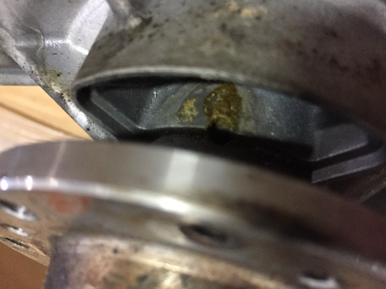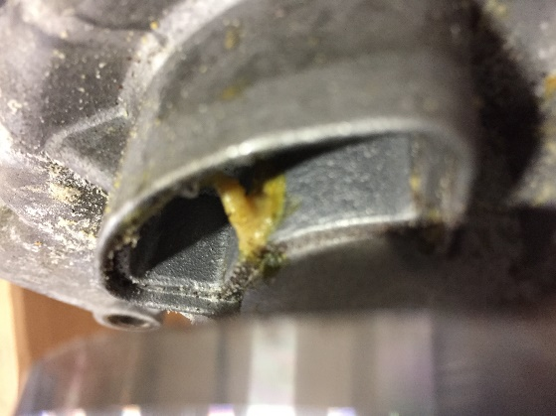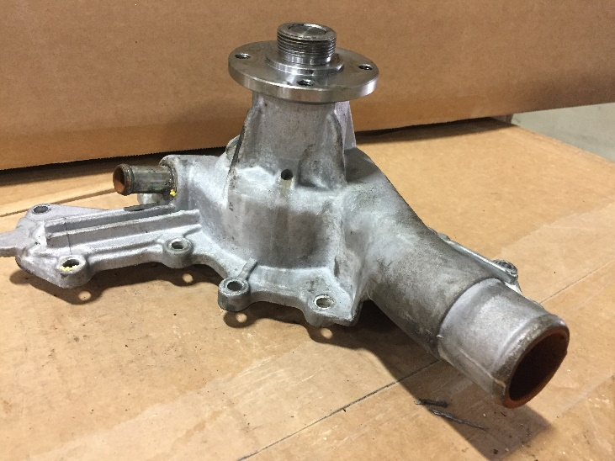
However, a steady drip or plow of coolant indicates coolant pump (seal) failure.

- Seal Overheating.

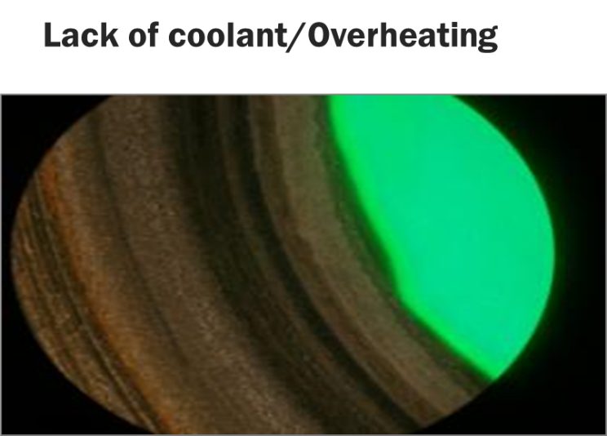

Heat aged and cracked bellows – plus circumference cracks between the seal contact face and outer seal diameter – indicate overheating conditions. Conditions leading to overheating type failures are:
  - Low coolant level.
  - Air entrapped in engine coolant at the coolant fill.
  - Coolant pump over speeding.

- Coolant Pump Oil and Grease Seal Failures.

Contributory conditions are:
  - Excessive amounts of grease used.
  - Wrong type of grease or oil used in bearings and grease cavity or contaminated lubricant
  - Improper assembly or installation of seal, wrong seal used, or quality defects in seal
  - Bearing failure

- Bearing Failure.

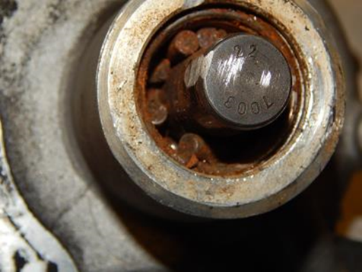

Contaminated coolant is the most common cause of coolant pump bearing failure. Contaminated coolant first causes coolant pump seal failure which then allows coolant and other contaminates to come into contact with the pump bearings. The bearings then quickly corrode and fail. Other factors that contribute to bearing failure are:
  - Dirt or contaminants in coolant pump lubricant
  - Improper coolant pump belt tension or drive failure
  - Excessive pump lubricant (grease).
  - Use of wrong lubricants.
  - Installation defect.

- Drive failure.

Conditions leading to drive failure are:
  - Belt groove wear due to dirt and debris
  - Imbalanced fan or pulley.
  - Misaligned pulleys.
  - Improper belt tension and/or mismatched belts

- Missing, loose or failed coolant pump supports.

- Electrolysis

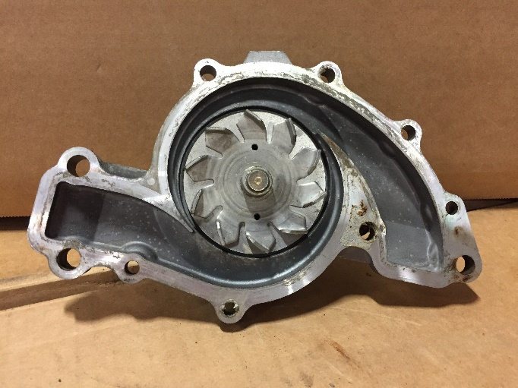

Need good definition of electrolysis and how to avoid and correct it.

Other failure modes:
High Load Low Cycle Failure
- Failure due to large cyclical force being applied:
- Extreme imbalance due to fan or fan clutch
- Mis-installed fan or fan clutch assembly
- Tensioner not moving causing belt tension to range from zero and extreme highs
- Locked center drive over tightened
How to identify this failure:
- Pitting seen over most of fracture surface
- Pitting appear to flow away from the initial break.
- Pitting over the entire shaft

Bending Fatigue Failure
Failure due to cyclical bending of shaft:
- Extreme imbalance due to fan or fan clutch
- Mis-installed fan or fan clutch assembly
- Tensioner not moving causing belt tension to range from zero and extreme highs

High Load Low Cycle/Bending Failure Repair
- Check all pulley and accessory component shafts for damage
- Check for proper belt length – make sure tensioner is in proper position
- Check for tensioner motion
- Lock center application - ensure belt tension is to manufacture specification
- Check and Replace fan and fan clutch assembly as needed.
Torsional Fracture Repair
- Clear any debris that may cause water pump to stop suddenly
- Check for signs of weep leakage
Over-use of silicon:
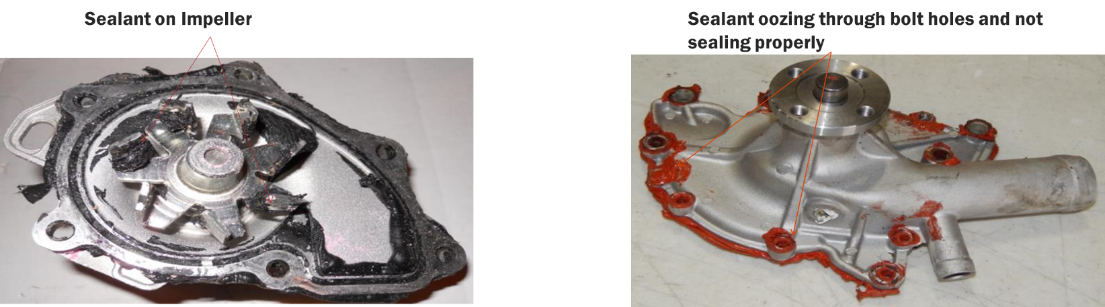

- Lose Silicon will enter the seal causing the seal to leak
- Gasket will not seal properly
- Silicon may get on the impeller effecting the flow rate

COOLING SYSTEM AND COOLANT CONDITION
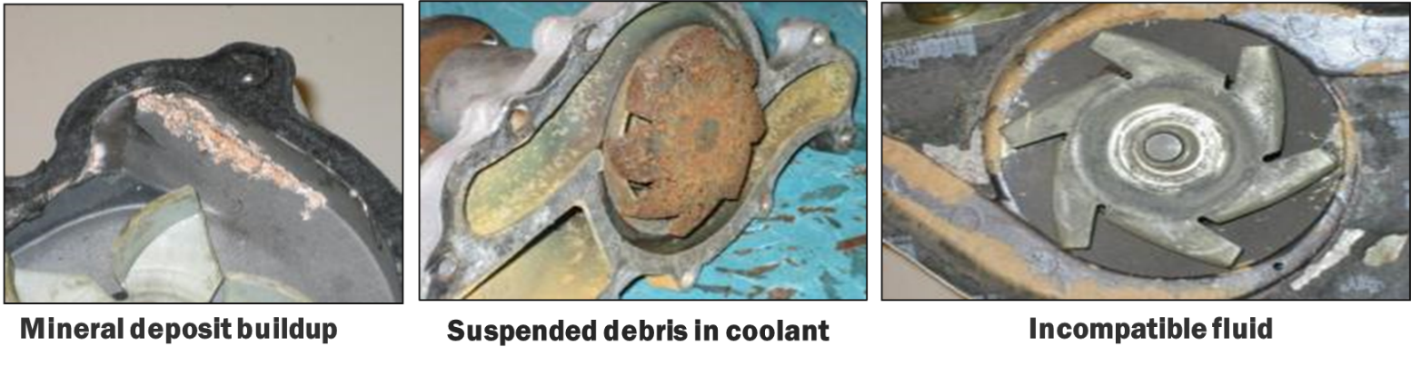
Many coolant pump failures are caused by poor coolant condition. Survey results have shown that most fleets have coolant maintenance programs, but 42% of these fleets do not have coolant analysis programs.
For testing the concentration or percentage of antifreeze in coolant, a refractometer is significantly more accurate than the best “float” or “ball” type testers. Forty percent of the fleets surveyed use refractometers. One-third of that 40 percent use float and ball type testers along with refractometers.
The condition of raw water (tap water, etc.) used in the coolant mix can affect seal life. Avoid the use of hard water not meeting specifications listed below as set by the Engine Manufacturers Association (EMA):
Total Hardness: <170 ppm of calcium and magnesium hardness
Chloride: <40 ppm
Sulfate: <100 ppm
TDS: <340 ppm

Flushing Statement

REFERENCE MATERIALS
Engine manufacturers publish reference materials on cooling system maintenance and coolant pumps. The following is a listing of some of these publications:
Caterpillar, Inc.:
- SEBV0554, Principles of Wear. This is a failure analysis book devoted to various component failures, including water pumps.
- SEBD0970, Coolant and Your Engine. This publication addresses preventive measures to help avoid coolant related failures.
- SEBU6250, Caterpillar Machine Fluids Recommendations.
NOTE: Caterpillar reports the three publications listed above are available from its dealers worldwide.
Cummins Engine Co.:
- 90T8-9, Cleaning Oil and Fuel Contamination from Engine Colling Systems
- 90T8-4, Coolant Recommendations
- 88T8-25, Water Pump Replacement Guidelines, 11/88
- “Cummins Service Bulletin 3666132-04 or latest version, Cummins Coolant Requirements and Maintenance.”
- “Cummins Engineering Standard CES14603 for Coolants in Cummins Engines.”
Detroit Diesel:
- 7SE 298, Coolant for Detroit Diesel Engines
- 18SA0353, Cooling System Guidelines for Detroit Diesel Corporation Radiator Cooled Engine Applications
NOTE: Detroit Diesel reports the publications listed above can be obtained from its dealers worldwide.
Mack Trucks, Inc.:
- TS49491, Maintenance and Lubrication
- 7.0, Engine Cooling System Service Manual
NOTE: Mack reports the publications listed above can be obtained from Mack dealers worldwide.

RELATED COOLING SYSTEM RPs:
RP 303A Silicone Hose
RP 328A Fleet Purchasing Specs for Nitrate-Containing Supplemental Coolant Additives (SCAs)
RP 329B Fleet Purchasing Specs for Nitrate-Containing Ethylene/Glycol Based Coolant
RP 311A Cold Weather Operation
RP 313D Checklist for Cooling System Maintenance
RP 319B General Guidelines and Precautions on SCAs
RP 326A Selecting Quality Recycled Engine Coolant
RP 332C Guidelines for Hoes Clamps and Fittings for Cooling/Charge Air Systems
RP 336A Aluminum Radiator Maintenance
RP 338B Extended Service Interval Coolants
RP 348A Coolant Hose Rating Factors
RP 362A Guidelines for Used Coolant Analysis of HD Vehicles
RP 365A Coolant Maintenance Guidelines
RP 368A Proper Coolant Draining and Filling Procedures for HD Diesel Engines

