RP 5xxx EXTENDED WARRANTY COST BENEFIT ANALYSIS
NOTE: The Extended Warranty Cost Benefit Analysis Calculator may be downloaded at the following link on TMC Connect – link insert here
Purpose and Scope:
The purpose of this Recommended Practice is to standardize guidelines for analyzing the cost benefit of Extended Warranty plans for commercial vehicles. These guidelines should provide basic information and terminology correlating directly to the Extended Warranty Cost Benefit Analysis Calculator.
Introductory Statement:
Through an analysis of VMRS data, a systematic calculation should be performed by a fleet or owner operator by deducting the cost of extended warranty packages from the corresponding warranty reimbursement amounts over an entire model year.
As a result, a calculator tool was developed to facilitate the input and automatic calculation of this data. This initiative functions as a practical tool for fleets or owner-operators to:
- evaluate the value of various warranty packages.
- extract trend data from previous packages.
- establish a basis for informed decision-making.
- shape the optimal warranty coverage for the fleet or owner-operator.
General Information:
To conduct a successful analysis, it is imperative to establish key parameters for the dataset such as defining the:
- optional interest rate
- the specified period
- cost per unit of the warranty package
The Extended Warranty Cost Benefit Analysis Calculator is a tailored template with set calculations and input fields and is customizable based on customer specifications, incorporating fields such as fleet size, ownership status, coverage types, and more. Input fields also include estimations for dealer and fleet warranty reimbursed totals, as well as approximations for expenditures on shop supplies, goodwill, or policy dollars.
Furthermore, essential data on the average dealership door rate, decommissioned mileage, and average monthly company miles contribute to a thorough analysis. Utilizing the Extended Warranty Cost Benefit Analysis Calculator, these insights are harnessed to obtain a net benefit per unit. With the support of this analysis, fleets or owner-operators can confidently make informed decisions, customizing their ideal coverage plan.
Tab- Summary Inputs
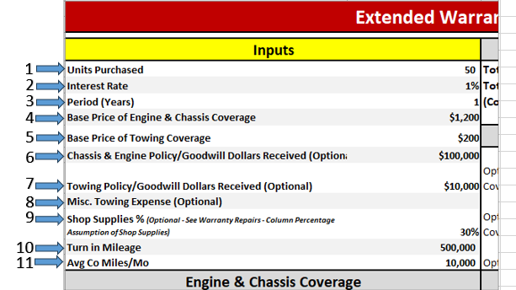
These inputs will calculate all the high-level cost benefit views in the remaining fields.
- Input units purchases within that Model Year
- Determine Interest rate - This would be a part of your purchase agreement.
- Determine Interest period - This would be a part of your purchase agreement.
- Determine Engine and Chassis Coverage Price from purchase on Spec Sheets, Facing Dealer and or Purchase agreement.
- Determine Towing Coverage Price from purchase on Spec Sheets, Facing Dealer and or Purchase agreement.
- Chassis and Engine Policy dollars received.
- Towing Policy dollars received.
- Misc towing expense amounts
- Shop supplies is an assumption and can be adjusted.
- Determine your turn in mileage.
- Average company miles a month.

Tab- Coverage Option Inputs
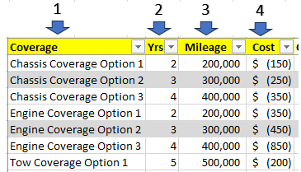
This input will pull over into column K, Product and Coverage Package, on the Warranty Repairs tab.
- Input coverage package options
- Input term years
- Input mileage coverage band
- Input cost per unit

Tab- Coverage Option Inputs
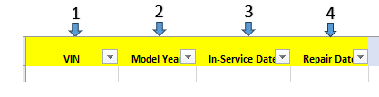
- Input all VINs within a target model year.
- Input the Model year.
- Input the in-service date. This can be provided by the OEM.
- Input the date of repair.
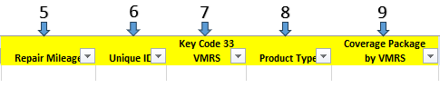
- Input the mileage at time of repair.
- Input the unique claim ID.
- Input Key Code 33 VMRS code for the repair.
- Input Product type. This can be determined if the repair was Chassis, Engine or Tow.
- Input the package that the VMRS is covered underneath.
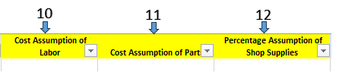
- Input the Cost assumption of Labor.
- Input the Cost assumption of Parts.
- Input the Percentage Assumption per claim of Shop Supplies.
Tab- Input Lists Inputs
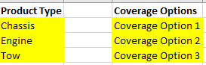
This input will be a matrix of all coverage options that pulls into column J, Coverage Package by VMRS, on the Warranty Repairs tab.
Glossary Terms:
Fleet Size - The total number of vehicles or assets owned or operated by a company or organization for business purposes. Fleet size can vary greatly depending on the nature of the business, ranging from a few vehicles for a small business to thousands for large corporations.
Ownership Status - Indicates whether a particular asset or property is owned outright, leased, rented, or otherwise controlled by an individual or organization. Ownership status often has implications for responsibilities, rights, and liabilities associated with the asset.
Warranty Coverage Types - Different categories or levels of protection provided by a warranty for products or services. Warranty coverage types can include manufacturer defects, parts replacement, labor costs, and specific timeframes during which repairs or replacements are covered.
Goodwill / Policy Dollars - Refers to the monetary value assigned to intangible assets such as a company's reputation, customer loyalty, brand recognition, or favorable relationships with stakeholders.
Average Dealership Door Rate - The average hourly non-warrantable labor rate charged by dealerships for repair and maintenance services. This rate typically includes the cost of labor performed by technicians, overhead expenses, and profit margins.
Decommissioned Mileage - The total distance traveled by a vehicle or asset from the time it was put into service until it is retired or decommissioned from active duty. Decommissioned mileage is often used as a measure of the asset's usage and wear and tear over its operational lifespan.
Average Monthly Company Miles - The average number of miles traveled by vehicles owned or operated by a company within a given month. This metric is often used to assess the efficiency of a company's fleet operations, monitor fuel consumption, and plan maintenance schedules.
Net Benefit Per Unit - The calculated gain or profit obtained from each individual unit or item within a given context, after accounting for all associated costs, expenses, and deductions. Net benefit per unit is commonly used in financial analysis to evaluate the profitability of products, services, or investments.

